UNITED STATES
SECURITIES AND EXCHANGE COMMISSION
Washington, D.C. 20549

Form 8-K

CURRENT REPORT
Pursuant to Section 13 or 15(d)
of the Securities Exchange Act of 1934
Date of Report (Date of earliest event reported): April 28, 2026

WAVE LIFE SCIENCES LTD.
(Exact name of registrant as specified in its charter)

Singapore |  | 001-37627 |  | 98-1356880
(State or other jurisdiction  of incorporation) |  | (Commission  File Number) |  | (IRS Employer  Identification No.)

7 Straits View #12-00, Marina One
East Tower  Singapore |  | 018936
(Address of principal executive offices) |  | (Zip Code)
Registrant’s telephone number, including area code: +65 6236 3388

Check the appropriate box below if the Form 8-K filing is intended to simultaneously satisfy the filing obligation of the registrant under any of the following provisions (see General Instruction A.2. below):

☐ | Written communications pursuant to Rule 425 under the Securities Act (17 CFR 230.425)

☐ | Soliciting material pursuant to Rule 14a-12 under the Exchange Act (17 CFR 240.14a-12)

☐ | Pre-commencement communications pursuant to Rule 14d-2(b) under the Exchange Act (17 CFR 240.14d-2(b))

☐ | Pre-commencement communications pursuant to Rule 13e-4(c) under the Exchange Act (17 CFR 240.13e-4(c))
Indicate by check mark whether the registrant is an emerging growth company as defined in Rule 405 of the Securities Act of 1933 (§230.405 of this chapter) or Rule 12b-2 of the Securities Exchange Act of 1934 (§240.12b-2 of this chapter).
Emerging growth company ☐
If an emerging growth company, indicate by check mark if the registrant has elected not to use the extended transition period for complying with any new or revised financial accounting standards provided pursuant to Section 13(a) of the Exchange Act. ☐
Securities registered pursuant to Section 12(b) of the Act:

Title of each class |  | Trading  symbol |  | Name of each exchange  on which registered
$0 Par Value Ordinary Shares |  | WVE |  | The Nasdaq Global Market

Item 2.02 | Results of Operations and Financial Condition.
On April 28, 2026, Wave Life Sciences Ltd. (the “Company”) announced its financial results for the quarter ended March 31, 2026. The full text of the press release issued in connection with the announcement is furnished as Exhibit 99.1 to this Current Report on Form 8-K and is incorporated by reference herein.

Item 7.01 | Regulation FD Disclosure.
From time to time, the Company presents and/or distributes slides and presentations to the investment community to provide updates and summaries of its business. On April 28, 2026, the Company updated its corporate presentation, which is available on the “Investors” section of the Company’s website at http://ir.wavelifesciences.com/. This presentation is also furnished as Exhibit 99.2 to this Current Report on Form 8-K
The information in these Items 2.02 and 7.01 are being furnished and shall not be deemed “filed” for purposes of Section 18 of the Securities Exchange Act of 1934, as amended (the “Exchange Act”), or otherwise subject to the liabilities of that Section, nor shall they be deemed incorporated by reference into any registration statement or other filing under the Securities Act of 1933, as amended, or the Exchange Act, except as shall be expressly set forth by specific reference in such filing.

Item 9.01 | Financial Statements and Exhibits.

(d) | Exhibits
The following exhibits relating to Items 2.02 and 7.01 are furnished and not filed:

Exhibit No. |  | Description
99.1 |  | Press Release issued by Wave Life Sciences Ltd. dated April 28, 2026
99.2 |  | Corporate Presentation of Wave Life Sciences Ltd. dated April 28, 2026
104 |  | Cover Page Interactive Data File (embedded within the Inline XBRL document)

SIGNATURES
Pursuant to the requirements of the Securities Exchange Act of 1934, the registrant has duly caused this report to be signed on its behalf by the undersigned hereunto duly authorized.

WAVE LIFE SCIENCES LTD.
By: |  | /s/ Kyle Moran, CFA
 |  | Kyle Moran, CFA
 |  | Chief Financial Officer
Date: April 28, 2026
Exhibit 99.1

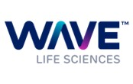
Wave Life Sciences Reports First Quarter 2026 Financial Results and Provides Business Update
With recent FDA acceptance of the Phase 2a multidose portion of INLIGHT trial of WVE-007 (INHBE GalNAc-siRNA) in individuals with higher BMI, with and without type 2 diabetes, this portion of the trial remains on track to initiate in 2Q 2026
Combination and maintenance trials of WVE-007 on track to initiate in 2026
Data from RestorAATion-2 trial of WVE-006 (GalNAc-RNA editing) in AATD (including 400 mg monthly dose and 600 mg single dose cohorts) to be presented at an investor webcast during the ATS International Conference in May 2026
Regulatory feedback on accelerated approval pathway for WVE-006 continues to be expected mid-2026
CTA submission for WVE-008 (GalNAc-RNA editing for PNPLA3 I148M liver disease) on track for 2026
Well capitalized with cash and cash equivalents of $544.6 million as of March 31, 2026 and expected cash runway into 3Q 2028
Investor conference call and webcast at 8:30 a.m. ET today
CAMBRIDGE, Mass., April 28, 2026 – Wave Life Sciences Ltd. (Nasdaq: WVE), a clinical-stage biotechnology company focused on unlocking the broad potential of RNA medicines to transform human health, today announced financial results for the first quarter ended March 31, 2026, and provided a business update.
“We’re accelerating WVE-007 to the next stages of development following the improvements in body composition already observed in the Phase 1 portion of our INLIGHT trial, including profound reductions in harmful visceral fat, along with favorable safety and potential for once to twice yearly dosing,” said Paul Bolno, MD, MBA, President and Chief Executive Officer at Wave Life Sciences. “This quarter, we expect to initiate the Phase 2a portion of INLIGHT in individuals with higher BMI and excess fat. Given WVE-007’s mechanism of targeted lipolysis, we believe this portion of the study can deliver even more pronounced improvements in body composition. Importantly, we’ve designed the Phase 2a study to assess additional biomarkers of cardiometabolic health, which will inform WVE-007’s broad potential across obesity and multiple indications, including MASH, type 2 diabetes, and cardiovascular disease. We also plan to rapidly initiate investigation of WVE-007 in both the combination and maintenance settings soon thereafter.”
Dr. Bolno added, “We continue to make significant progress advancing our RNA editing pipeline led by WVE-006 for AATD. Clinical data from our ongoing RestorAATion-2 trial of WVE-006 has already demonstrated the potential to provide a much-needed new therapeutic option. By correcting the root cause of disease, WVE-006 restores dynamic AAT production to address lung manifestations and lowers harmful Z-AAT to address liver manifestations of the disease, with a therapy that is well-tolerated, non-permanent, and highly specific. WVE-006 also avoids delivery with LNPs and collateral bystander edits and indels associated with DNA base editing. In May, we expect

to highlight data from our RestorAATion-2 trial, including results from our less frequent, 400 mg monthly dose and 600 mg single dose cohorts. We remain on track to receive regulatory feedback on a potential accelerated approval pathway for WVE-006 mid-year. Building on our clinical success in RNAi and RNA editing, we are advancing WVE-008, as well as a pipeline of additional hepatic and extra-hepatic siRNAs and AIMers.”
Recent Business Highlights and Expected Milestones
Obesity

 |  |  | WVE-007 is an investigational GalNAc-siRNA (SpiNA design) designed to silence INHBE mRNA to induce fat loss without muscle loss, a promising therapeutic strategy to treat obesity with strong evidence from human genetics. WVE-007 is being evaluated in the ongoing placebo-controlled INLIGHT clinical trial.

 |  |  | Phase 1 INLIGHT: In March 2026, Wave announced interim results from the ongoing Phase 1, single-ascending dose portion of its INLIGHT trial in healthy individuals with overweight or obesity (average BMI of ~32 kg/m2, a population with less fat and lower BMI than those in Phase 2 and Phase 3 obesity studies), which showed further improvements in body composition at six months following a single dose of WVE-007. WVE-007 continued to be generally safe and well tolerated. At six-month follow-up, a single 240 mg dose of WVE-007 demonstrated continued total body fat reduction (-5.3%) with muscle preservation (+2.4%), as well as clinically meaningful reductions in visceral fat (-14.3%; p<0.05) and waist circumference (-3.3%) – exceeding the 5–10% visceral fat reductions that support robust correlations to clinical outcomes (lower risk of MASH, T2D, and CVD)1. Preservation of muscle is a key differentiator from incretin treatments and is linked to health benefits including higher basal metabolic rate, improved insulin sensitivity, and prevention of weight regain. Activin E reductions were robust and durable and continue to support potential for once or twice-yearly dosing.

 |  |  | Additional data from INLIGHT, including data from the 600 mg Phase 1 SAD cohort, are expected in 2026.

 |  |  | Phase 2a INLIGHT: The U.S. Food and Drug Administration (FDA) has accepted the Phase 2a multidose portion of INLIGHT trial of WVE-007 (INHBE GalNAc-siRNA) in individuals with higher BMI (35-50 kg/m2) with and without type 2 diabetes. This placebo-controlled (3:1) portion of the trial will include multiple assessments over a 12-month period, including body weight, waist circumference, body composition (MRI and DEXA), liver fat (MRI-PDFF), HbA1c, lipid levels, CRP, and muscle function, with a first assessment at three months following the first dose. Data from the Phase 2a study will inform further development of WVE-007 in obesity, as well as in MASH, type 2 diabetes, and cardiovascular disease.

 |  |  | Wave is on track to initiate the Phase 2a portion of INLIGHT in the second quarter of 2026.

 |  |  | Combination with incretin and post-incretin maintenance studies of WVE-007 are expected to initiate in 2026.
AATD (Alpha-1 antitrypsin deficiency)

 |  |  | WVE-006 is an investigational GalNAc-conjugated, subcutaneously delivered, RNA editing oligonucleotide (AIMer) for AATD. The RestorAATion-2 clinical trial is fully enrolled through the 600 mg cohort, and dosing is complete in the single dose portion.

 |  |  | Clinical data from the 200 mg (single and biweekly) and 400 mg (single dose) cohorts of the ongoing RestorAATion-2 clinical trial have demonstrated WVE-006 achieved key AATD treatment goals by recapitulating an MZ-like phenotype, characterized by basal AAT levels above 11 µM, wild-type M-AAT above 50% of total AAT, reduction of Z-AAT protein, and dynamic AAT production during an acute phase

response. These data will be included at multiple upcoming medical meetings including in a late-breaking oral presentation at the American Thoracic Society (ATS) International Conference (Dr. Kenneth R. Chapman, MsC, MD, FRCPC, FACP, FERS, Department of Medicine, University of Toronto) on May 18, 2026 and in an oral presentation at the European Association for the Study of the Liver (EASL) Congress (Dr. Pavel Strnad, MD, Professor of Translational Gastroenterology and Senior Physician at the University Hospital Aachen, Department of Medicine III) on May 29, 2026.

 |  |  | Wave will hold an investor conference call and webcast at 5:30 p.m. ET on May 18, 2026 to highlight its AATD program, including new clinical data from the 400 mg multidose cohort and 600 mg single dose cohort of RestorAATion-2. Wave also expects to share data from the 600 mg multidose cohort in the second half of 2026.

 |  |  | Wave expects to receive regulatory feedback on a potential accelerated approval pathway mid-2026.
PNPLA3 I148M liver disease

 |  |  | WVE-008: Wave is building on its clinical success in RNA editing by advancing WVE-008, a GalNAc-conjugated AIMer for homozygous PNPLA3 I148M liver disease.

 |  |  | Wave will highlight preclinical data supporting WVE-008 in a poster presentation at the EASL Congress.

 |  |  | Clinical trial application (CTA) filing for WVE-008 is on track for 2026.
DMD (exon 53)

 |  |  | WVE-N531: Wave remains on track to file a New Drug Application (NDA) in 2026 to support accelerated approval of WVE-N531 with monthly dosing.
Bifunctional modality

 |  |  | Wave is applying learnings from across its platform and chemistry optimization to investigate new bifunctional modalities which combine RNAi and RNA editing or dual RNAi silencing into a single oligonucleotide construct. These constructs are designed to silence multiple targets or silence one target while simultaneously editing or upregulating another distinct target. Wave expects to provide further updates on its bifunctional modality in 2026.
Financial Highlights

 |  |  | Cash and cash equivalents were $544.6 million as of March 31, 2026, compared to $602.1 million as of December 31, 2025. Wave expects that its current cash and cash equivalents will be sufficient to fund operations into the third quarter of 2028. Potential future milestone and other payments to Wave under its GSK collaboration are not included in its cash runway.

 |  |  | Revenue recognized was $38.2 million for the first quarter of 2026 as compared to $9.2 million in the prior year quarter.

 |  |  | Research and development expenses were $47.4 million in the first quarter of 2026 as compared to $40.6 million in the same period in 2025.

 |  |  | General and administrative expenses were $22.1 million in the first quarter of 2026 as compared to $18.4 million in the same period in 2025.

 |  |  | Net loss was $26.1 million for the first quarter of 2026 as compared to a net loss of $46.9 million in the prior year quarter.

Investor Conference Call and Webcast
Wave will host an investor conference call today at 8:30 a.m. ET to review the first quarter 2026 financial results and pipeline updates. A webcast of the conference call can be accessed by visiting “Investor Events” on the investor relations section of the Wave Life Sciences website: https://ir.wavelifesciences.com/events-publications/events. Analysts planning to participate during the Q&A portion of the live call can join the conference call at the audio-conferencing link here. Following the live event, an archived version of the webcast will be available on the Wave Life Sciences website.
About Wave Life Sciences
Wave Life Sciences (Nasdaq: WVE) is a biotechnology company focused on unlocking the broad potential of RNA medicines to transform human health. Wave’s RNA medicines platform, PRISM®, combines multiple modalities, chemistry innovation and deep insights in human genetics to deliver scientific breakthroughs that treat both rare and common disorders. Its toolkit of RNA-targeting modalities, including RNAi (SpiNA) and RNA editing (AIMers), provides Wave with unmatched capabilities for designing and sustainably delivering candidates that optimally address disease biology. Wave’s pipeline is focused on its obesity (WVE-007), alpha-1 antitrypsin deficiency (WVE-006) and PNPLA3 I148M liver disease (WVE-008) programs, and also includes clinical programs in Duchenne muscular dystrophy and Huntington’s disease, as well as several preclinical programs utilizing the company’s versatile RNA medicines platform. Driven by the calling to “Reimagine Possible,” Wave is leading the charge toward a world in which human potential is no longer hindered by the burden of disease. Wave is headquartered in Cambridge, MA. For more information on Wave’s science, pipeline and people, please visit www.wavelifesciences.com and follow Wave on X and LinkedIn.

Forward-Looking Statements
This press release contains forward-looking statements within the meaning of the Private Securities Litigation Reform Act of 1995, as amended, concerning our goals, beliefs, expectations, strategies, objectives and plans, and other statements that are not necessarily based on historical facts, including statements regarding the following, among others: the anticipated initiation, timing, design, progress, data and announcements related to our clinical trials, including interactions with and feedback from regulators and any potential registrational submissions based on these data; the future performance and results of our programs in clinical trials, including the anticipated therapeutic benefits of such programs, and our expectations with respect to how our clinical data may predict success for our future therapeutic candidates and data readouts; the potential commercialization of our programs the potential size of the markets that our therapeutics may address; preclinical activities and programs and their potential to transition into clinical-stage programs, and the timing, progress and announcement of such events; the progress and potential benefits, including the potential achievement of milestones, of collaborations and strategic partnerships; the expected benefits of our stereopure oligonucleotides compared with stereorandom oligonucleotides; the breadth and versatility of our PRISM® drug discovery and development platform; the potential benefits of our RNA-targeting modalities, including RNAi (SpiNA), RNA editing (AIMers), and our bifunctional modalities; the potential for certain of our programs to be best-in-class or first-in-class, or to change the existing treatment paradigm or show substantial benefits over existing standards of care; our financial performance, including the anticipated duration of our cash runway and our ability to fund future operations; our intended uses of capital; and our expectations regarding the impact of any potential global macro events on our business. The words “may,” “will,” “could,” “would,” “should,” “expect,” “plan,” “anticipate,” “intend,” “believe,” “estimate,” “predict,” “project,” “potential,” “continue,” “target” and similar expressions are intended to identify forward-looking statements, although not all forward-looking statements contain these identifying words. Any forward-looking statements in this press release are based on management’s current expectations and beliefs and are subject to a number of risks, uncertainties and important factors that may cause actual results to differ materially from those indicated by these forward-looking statements as a result of these risks, uncertainties and important factors, including, without limitation, the clinical results and timing of our programs, which may not support further development of our product candidates; actions of regulatory agencies, which may affect the initiation, timing and progress of clinical trials; our effectiveness in managing current and future clinical trials and regulatory processes; the continued development and acceptance of nucleic acid therapeutics as a class of drugs; our ability to demonstrate the therapeutic benefits of our stereopure candidates in clinical trials, including our ability to develop candidates across multiple therapeutic modalities; our ability to obtain, maintain and protect intellectual property; our ability to fund our operations and to raise additional capital as needed; competition from others developing therapies for similar uses; and any impacts on our business as a result of or related to any global economic uncertainty or market disruptions, as well as the other risks and uncertainties described in the section entitled “Risk Factors” in our most recent Annual Report on Form 10-K filed with the Securities and Exchange Commission (SEC), as amended, and in other filings we make with the SEC from time to time. In addition, any forward-looking statements represent our views only as of today and should not be relied upon as representing our views as of any subsequent date. We undertake no obligation, except to the extent required by law, to update the information contained in this press release to reflect subsequently occurring events or circumstances.

Contact:
Kate Rausch
VP, Corporate Affairs and Investor Relations
+1 617-949-4827
Investors:
James Salierno
Director, Investor Relations
+1 617-949-4043
InvestorRelations@wavelifesci.com
Media:
Katie Sullivan
Senior Director, Corporate Communications
+1 617-949-2936
MediaRelations@wavelifesci.com

1 | Gabriely et al., Diabetes 2002; Campos et al., Diabetes & Vascular Disease Research 2019; Huang et al., Front Endocrinol 2023.; Cesaro et al., Front Cardiovasc Med 2023; Khawaja et, al., Curr Cardiol Rep 2024; Hiuge-Shimizu et al., J Atheroscler Thromb 2011.; Liao et al., PLoS ONE 2023; Jung et al., Endocrinol Metab 2020; Hanlon & Yuan, Clin Liver Dis 2021.; Liao et al., PLoS ONE 2023; Jung et al., Endocrinol Metab 2020

WAVE LIFE SCIENCES LTD.
UNAUDITED CONSOLIDATED BALANCE SHEETS
(In thousands, except share amounts)

 |  | March 31, 2026 |  |  |  | December 31, 2025
Assets
Current assets:
Cash and cash equivalents |  | $ | 544,591 |  |  | $ | 602,068
Accounts receivable |  |  | — |  |  |  | 1,276
Prepaid expenses |  |  | 13,225 |  |  |  | 8,395
Other current assets |  |  | 3,456 |  |  |  | 3,075
Total current assets |  |  | 561,272 |  |  |  | 614,814
Long-term assets:
Property and equipment, net of accumulated depreciation of $50,352 and $49,522 as of March 31, 2026 and December 31, 2025, respectively |  |  | 7,077 |  |  |  | 7,405
Operating lease right-of-use assets |  |  | 10,994 |  |  |  | 12,458
Restricted cash |  |  | 3,815 |  |  |  | 3,806
Other assets |  |  | 386 |  |  |  | 16
Total long-term assets |  |  | 22,272 |  |  |  | 23,685
Total assets |  | $ | 583,544 |  |  | $ | 638,499
Liabilities, Series A preferred shares, and shareholders’ equity
Current liabilities:
Accounts payable |  | $ | 19,064 |  |  | $ | 15,700
Accrued expenses and other current liabilities |  |  | 13,043 |  |  |  | 26,564
Current portion of deferred revenue |  |  | 9,396 |  |  |  | 44,440
Current portion of operating lease liability |  |  | 8,328 |  |  |  | 8,361
Total current liabilities |  |  | 49,831 |  |  |  | 95,065
Long-term liabilities:
Deferred revenue, net of current portion |  |  | 14,596 |  |  |  | 7,798
Operating lease liability, net of current portion |  |  | 7,387 |  |  |  | 9,405
Total long-term liabilities |  |  | 21,983 |  |  |  | 17,203
Total liabilities |  | $ | 71,814 |  |  | $ | 112,268
Series A preferred shares, no par value; nil and 3,901,348 shares issued and outstanding at March 31, 2026 and December 31, 2025, respectively |  | $ | — |  |  | $ | 7,874
Shareholders’ equity:
Ordinary shares, no par value; 192,337,566 and 187,660,263 shares issued and outstanding at March 31, 2026 and December 31, 2025, respectively |  | $ | 1,626,879 |  |  | $ | 1,616,478
Additional paid-in capital |  |  | 237,428 |  |  |  | 228,365
Accumulated other comprehensive loss |  |  | (254 | ) |  |  | (250 | )
Accumulated deficit |  |  | (1,352,323 | ) |  |  | (1,326,236 | )
Total shareholders’ equity |  | $ | 511,730 |  |  | $ | 518,357
Total liabilities, Series A preferred shares, and shareholders’ equity |  | $ | 583,544 |  |  | $ | 638,499
The accompanying notes are an integral part of the consolidated financial statements.

WAVE LIFE SCIENCES LTD.
UNAUDITED CONSOLIDATED STATEMENTS OF OPERATIONS AND COMPREHENSIVE LOSS
(In thousands, except share and per share amounts)

 |  | Three Months Ended March 31,
 |  | 2026 |  |  |  | 2025
Revenue |  | $ | 38,246 |  |  | $ | 9,175
Operating expenses:
Research and development |  |  | 47,440 |  |  |  | 40,622
General and administrative |  |  | 22,104 |  |  |  | 18,357
Total operating expenses |  |  | 69,544 |  |  |  | 58,979
Loss from operations |  |  | (31,298 | ) |  |  | (49,804 | )
Other income, net:
Interest income |  |  | 5,291 |  |  |  | 2,875
Other income (expense), net |  |  | (80 | ) |  |  | 51
Total other income, net |  |  | 5,211 |  |  |  | 2,926
Loss before income taxes |  |  | (26,087 | ) |  |  | (46,878 | )
Income tax benefit |  |  | — |  |  |  | —
Net loss |  | $ | (26,087 | ) |  | $ | (46,878 | )
Net loss per share attributable to ordinary shareholders—basic and diluted |  | $ | (0.13 | ) |  | $ | (0.29 | )
Weighted-average ordinary shares used in computing net loss per share attributable to ordinary shareholders—basic and diluted |  |  | 200,167,869 |  |  |  | 162,572,026
Other comprehensive income (loss):
Net loss |  | $ | (26,087 | ) |  | $ | (46,878 | )
Foreign currency translation gain (loss) |  |  | (4 | ) |  |  | 58
Comprehensive loss |  | $ | (26,091 | ) |  | $ | (46,820 | )
The accompanying notes are an integral part of the consolidated financial statements.

Exhibit 99.2 Wave Life Sciences Corporate Presentation April 28, 2026


Forward-looking statements This document contains forward-looking statements. All statements other than statements of historical facts contained in this document, including statements regarding possible or assumed future results of operations, preclinical and clinical studies, business strategies, research and development plans, collaborations and partnerships, regulatory activities and timing thereof, competitive position, potential growth opportunities, use of proceeds and the effects of competition are forward-looking statements. These statements involve known and unknown risks, uncertainties and other important factors that may cause the actual results, performance or achievements of Wave Life Sciences Ltd. (the “Company”) to be materially different from any future results, performance or achievements expressed or implied by the forward-looking statements. In some cases, you can identify forward-looking statements by terms such as “may,” “will,” “should,” “expect,” “plan,” “aim,” “anticipate,” “could,” “intend,” “target,” “project,” “contemplate,” “believe,” “estimate,” “predict,” “potential” or “continue” or the negative of these terms or other similar expressions. The forward- looking statements in this presentation are only predictions. The Company has based these forward-looking statements largely on its current expectations and projections about future events and financial trends that it believes may affect the Company’s business, financial condition and results of operations. These forward-looking statements speak only as of the date of this presentation and are subject to a number of risks, uncertainties and assumptions, including those listed under Risk Factors in the Company’s Form 10-K and other filings with the SEC, some of which cannot be predicted or quantified and some of which are beyond the Company’s control. The events and circumstances reflected in the Company’s forward-looking statements may not be achieved or occur, and actual results could differ materially from those projected in the forward-looking statements. Moreover, the Company operates in a dynamic industry and economy. New risk factors and uncertainties may emerge from time to time, and it is not possible for management to predict all risk factors and uncertainties that the Company may face. Except as required by applicable law, the Company does not plan to publicly update or revise any forward-looking statements contained herein, whether as a result of any new information, future events, changed circumstances or otherwise. 2


Our Mission To unlock the broad potential of RNA medicines to transform human health 3

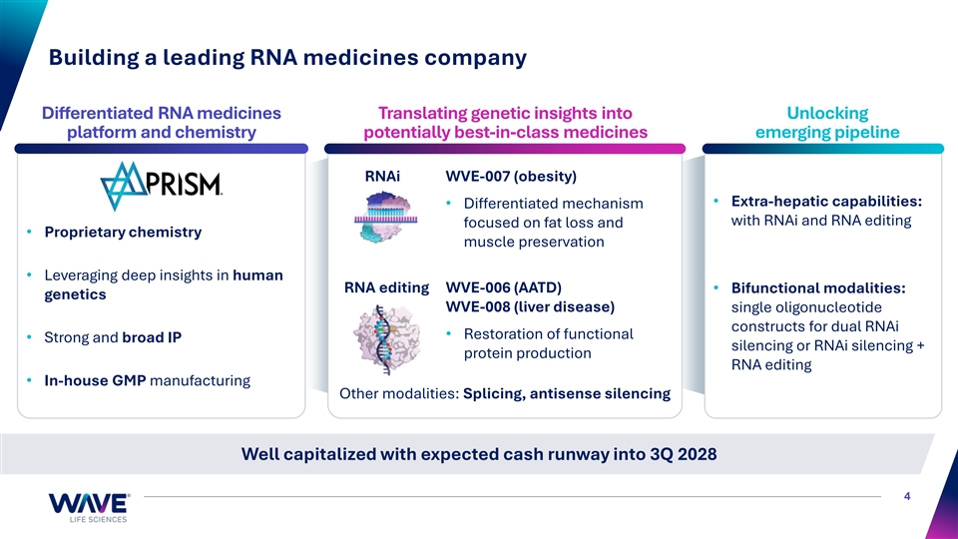
Building a leading RNA medicines company Differentiated RNA medicines Translating genetic insights into Unlocking platform and chemistry potentially best-in-class medicines emerging pipeline RNAi WVE-007 (obesity) • Extra-hepatic capabilities: • Differentiated mechanism with RNAi and RNA editing focused on fat loss and • Proprietary chemistry muscle preservation • Leveraging deep insights in human RNA editing WVE-006 (AATD) • Bifunctional modalities: genetics WVE-008 (liver disease) single oligonucleotide constructs for dual RNAi • Restoration of functional • Strong and broad IP silencing or RNAi silencing + protein production RNA editing • In-house GMP manufacturing Other modalities: Splicing, antisense silencing Well capitalized with expected cash runway into 3Q 2028 4

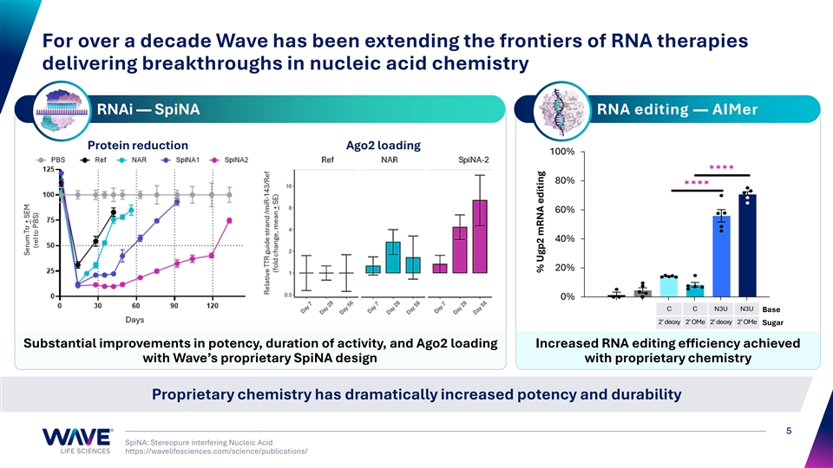
For over a decade Wave has been extending the frontiers of RNA therapies delivering breakthroughs in nucleic acid chemistry RNAi — SpiNA RNA editing — AIMer Protein reduction Ago2 loading 100% 80% 60% 40% 20% 0% C C N3U N3U Base 2’ deoxy 2’ OMe 2’ deoxy 2’ OMe Sugar Substantial improvements in potency, duration of activity, and Ago2 loading Increased RNA editing efficiency achieved with Wave’s proprietary SpiNA design with proprietary chemistry Proprietary chemistry has dramatically increased potency and durability 5 SpiNA: Stereopure interfering Nucleic Acid https://wavelifesciences.com/science/publications/ % Ugp2 mRNA editing

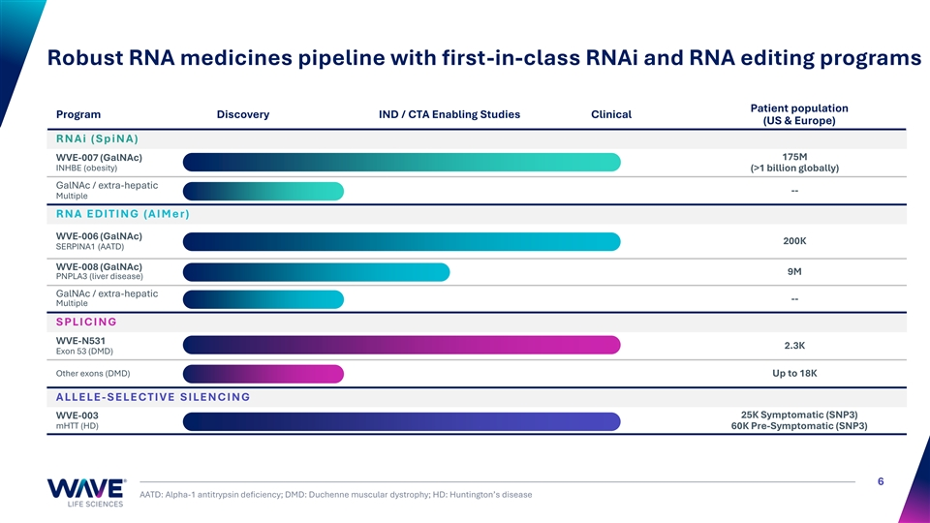
Robust RNA medicines pipeline with first-in-class RNAi and RNA editing programs Patient population Program Discovery IND / CTA Enabling Studies Clinical (US & Europe) R N A i ( S p i N A ) 175M WVE-007 (GalNAc) INHBE (obesity) (>1 billion globally) GalNAc / extra-hepatic -- Multiple R N A E D I T I N G ( A I M e r ) WVE-006 (GalNAc) 200K SERPINA1 (AATD) WVE-008 (GalNAc) 9M PNPLA3 (liver disease) GalNAc / extra-hepatic -- Multiple S PLI C I N G WVE-N531 2.3K Exon 53 (DMD) Other exons (DMD) Up to 18K A LLE LE - S E LE C T I V E S I LE N C I N G WVE-003 25K Symptomatic (SNP3) mHTT (HD) 60K Pre-Symptomatic (SNP3) 6 AATD: Alpha-1 antitrypsin deficiency; DMD: Duchenne muscular dystrophy; HD: Huntington’s disease


WVE-007 GalNAc-siRNA silencing Obesity 7

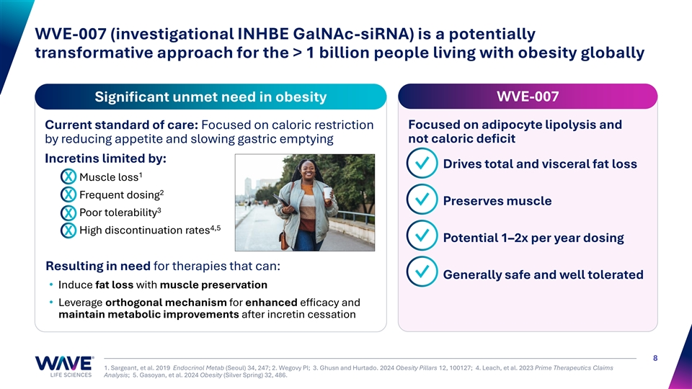
WVE-007 (investigational INHBE GalNAc-siRNA) is a potentially transformative approach for the > 1 billion people living with obesity globally Significant unmet need in obesity WVE-007 Focused on adipocyte lipolysis and Current standard of care: Focused on caloric restriction by reducing appetite and slowing gastric emptying not caloric deficit Incretins limited by: Drives total and visceral fat loss ✓ 1 Muscle loss X 2 X Frequent dosing Preserves muscle ✓ 3 Poor tolerability X 4,5 High discontinuation rates X Potential 1–2x per year dosing ✓ Resulting in need for therapies that can: ✓ Generally safe and well tolerated • Induce fat loss with muscle preservation • Leverage orthogonal mechanism for enhanced efficacy and maintain metabolic improvements after incretin cessation 8 1. Sargeant, et al. 2019 Endocrinol Metab (Seoul) 34, 247; 2. Wegovy PI; 3. Ghusn and Hurtado. 2024 Obesity Pillars 12, 100127; 4. Leach, et al. 2023 Prime Therapeutics Claims Analysis; 5. Gasoyan, et al. 2024 Obesity (Silver Spring) 32, 486.

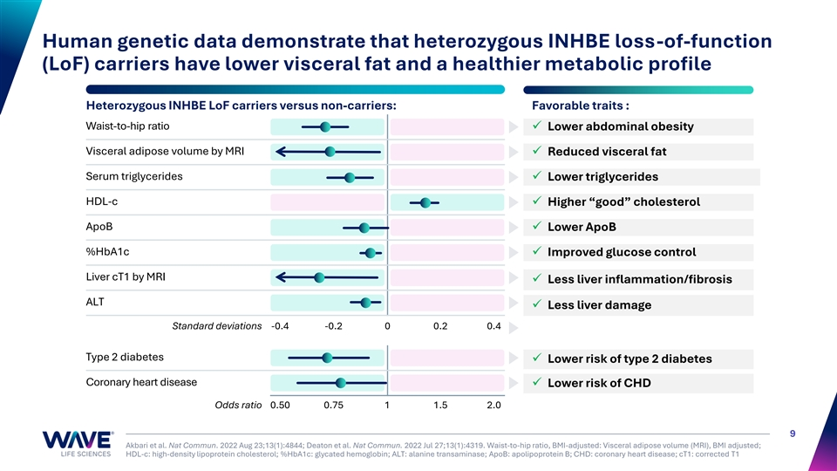
Human genetic data demonstrate that heterozygous INHBE loss-of-function (LoF) carriers have lower visceral fat and a healthier metabolic profile Heterozygous INHBE LoF carriers versus non-carriers: Favorable traits : Waist-to-hip ratio✓ Lower abdominal obesity Visceral adipose volume by MRI ✓ Reduced visceral fat Serum triglycerides ✓ Lower triglycerides HDL-c ✓ Higher “good” cholesterol ApoB ✓ Lower ApoB %HbA1c✓ Improved glucose control Liver cT1 by MRI ✓ Less liver inflammation/fibrosis ALT ✓ Less liver damage Standard deviations -0.4 -0.2 0 0.2 0.4 Type 2 diabetes ✓ Lower risk of type 2 diabetes Coronary heart disease ✓ Lower risk of CHD Odds ratio 0.50 0.75 1 1.5 2.0 9 Akbari et al. Nat Commun. 2022 Aug 23;13(1):4844; Deaton et al. Nat Commun. 2022 Jul 27;13(1):4319. Waist-to-hip ratio, BMI-adjusted: Visceral adipose volume (MRI), BMI adjusted; HDL-c: high-density lipoprotein cholesterol; %HbA1c: glycated hemoglobin; ALT: alanine transaminase; ApoB: apolipoprotein B; CHD: coronary heart disease; cT1: corrected T1

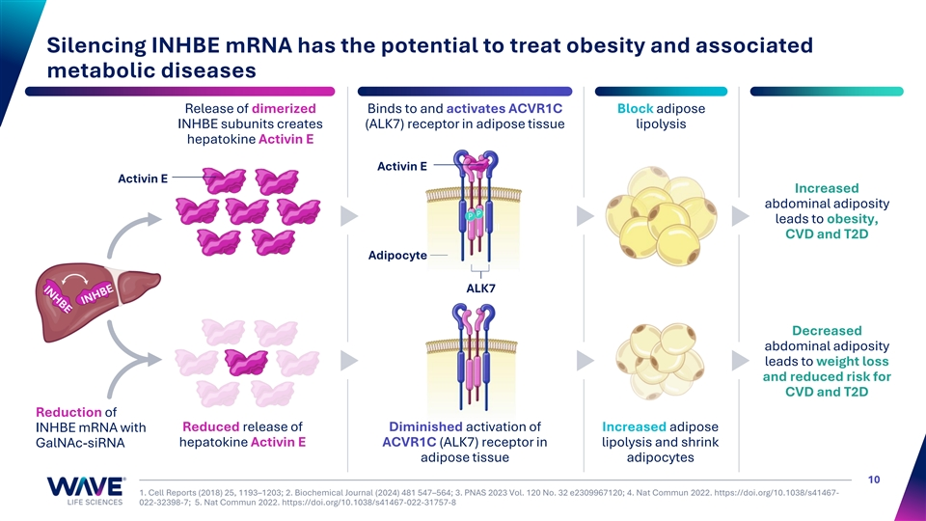
Silencing INHBE mRNA has the potential to treat obesity and associated metabolic diseases Release of dimerized Binds to and activates ACVR1C Block adipose INHBE subunits creates (ALK7) receptor in adipose tissue lipolysis hepatokine Activin E Activin E Activin E Increased abdominal adiposity leads to obesity, I II I I CVD and T2D Adipocyte ALK7 Decreased abdominal adiposity leads to weight loss and reduced risk for CVD and T2D Reduction of Reduced release of Diminished activation of Increased adipose INHBE mRNA with hepatokine Activin E ACVR1C (ALK7) receptor in lipolysis and shrink GalNAc-siRNA adipose tissue adipocytes 10 1. Cell Reports (2018) 25, 1193–1203; 2. Biochemical Journal (2024) 481 547–564; 3. PNAS 2023 Vol. 120 No. 32 e2309967120; 4. Nat Commun 2022. https://doi.org/10.1038/s41467- 022-32398-7; 5. Nat Commun 2022. https://doi.org/10.1038/s41467-022-31757-8

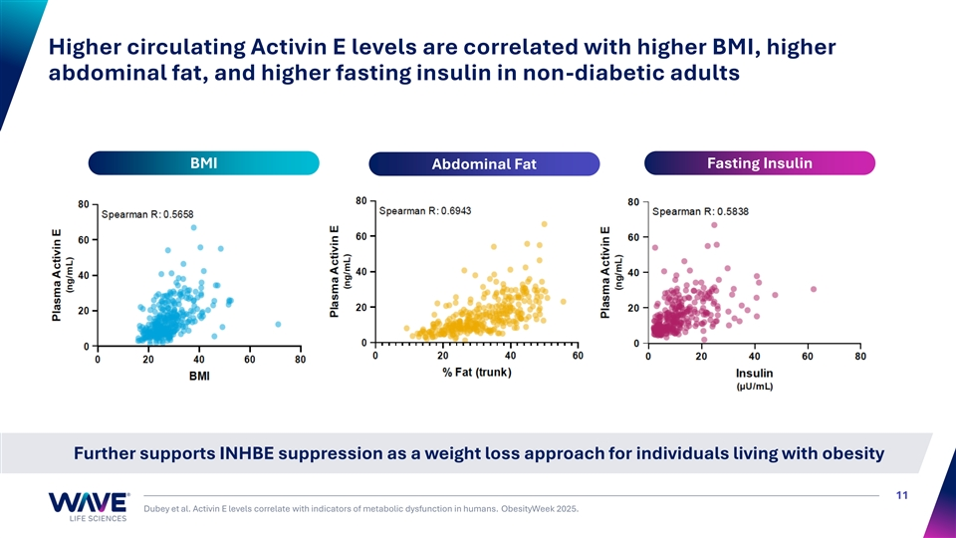
Higher circulating Activin E levels are correlated with higher BMI, higher abdominal fat, and higher fasting insulin in non-diabetic adults BMI Fasting Insulin Abdominal Fat Further supports INHBE suppression as a weight loss approach for individuals living with obesity 11 Dubey et al. Activin E levels correlate with indicators of metabolic dysfunction in humans. ObesityWeek 2025.

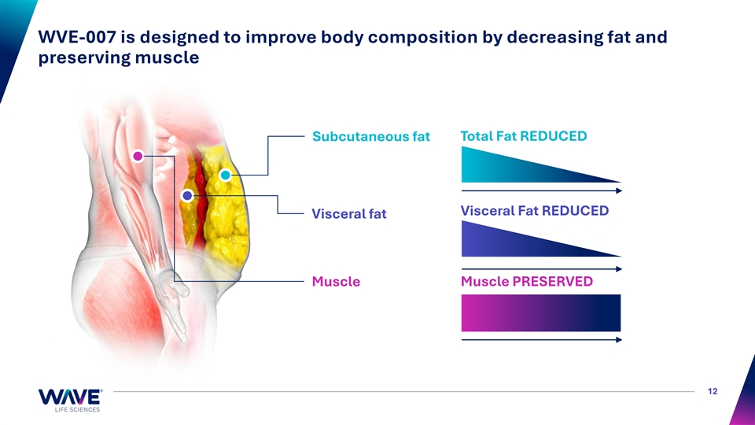
WVE-007 is designed to improve body composition by decreasing fat and preserving muscle Total Fat REDUCED Subcutaneous fat Visceral Fat REDUCED Visceral fat Muscle Muscle PRESERVED 12

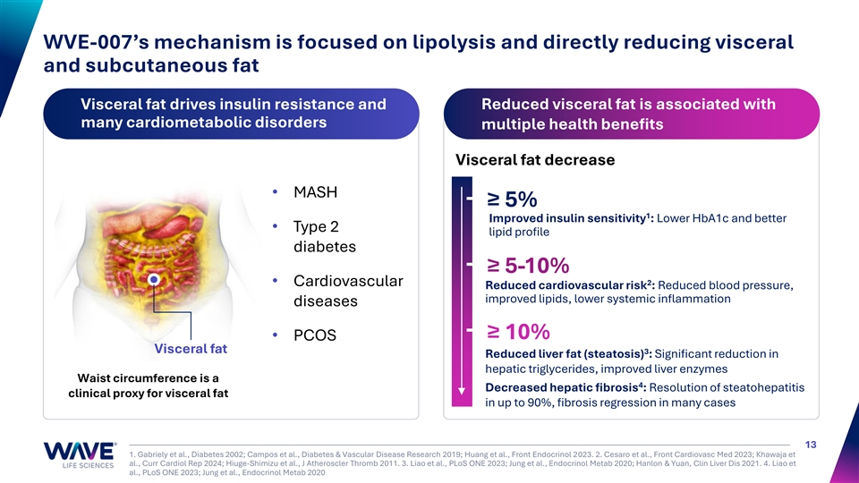
WVE-007’s mechanism is focused on lipolysis and directly reducing visceral and subcutaneous fat Visceral fat drives insulin resistance and Reduced visceral fat is associated with many cardiometabolic disorders multiple health benefits Visceral fat decrease • MASH ≥ 5% 1 Improved insulin sensitivity : Lower HbA1c and better • Type 2 lipid profile diabetes ≥ 5-10% • Cardiovascular 2 Reduced cardiovascular risk : Reduced blood pressure, improved lipids, lower systemic inflammation diseases ≥ 10% • PCOS Visceral fat 3 Reduced liver fat (steatosis) : Significant reduction in hepatic triglycerides, improved liver enzymes Waist circumference is a 4 Decreased hepatic fibrosis : Resolution of steatohepatitis clinical proxy for visceral fat in up to 90%, fibrosis regression in many cases 13 1. Gabriely et al., Diabetes 2002; Campos et al., Diabetes & Vascular Disease Research 2019; Huang et al., Front Endocrinol 2023. 2. Cesaro et al., Front Cardiovasc Med 2023; Khawaja et al., Curr Cardiol Rep 2024; Hiuge-Shimizu et al., J Atheroscler Thromb 2011. 3. Liao et al., PLoS ONE 2023; Jung et al., Endocrinol Metab 2020; Hanlon & Yuan, Clin Liver Dis 2021. 4. Liao et al., PLoS ONE 2023; Jung et al., Endocrinol Metab 2020

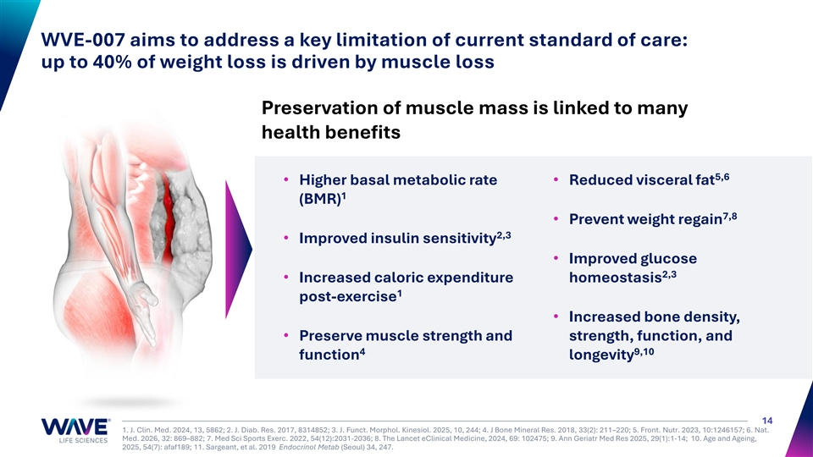
WVE-007 aims to address a key limitation of current standard of care: up to 40% of weight loss is driven by muscle loss Preservation of muscle mass is linked to many health benefits 5,6 • Higher basal metabolic rate • Reduced visceral fat 1 (BMR) 7,8 • Prevent weight regain 2,3 • Improved insulin sensitivity • Improved glucose 2,3 • Increased caloric expenditure homeostasis 1 post-exercise • Increased bone density, • Preserve muscle strength and strength, function, and 4 9,10 function longevity 14 1. J. Clin. Med. 2024, 13, 5862; 2. J. Diab. Res. 2017, 8314852; 3. J. Funct. Morphol. Kinesiol. 2025, 10, 244; 4. J Bone Mineral Res. 2018, 33(2): 211–220; 5. Front. Nutr. 2023, 10:1246157; 6. Nat. Med. 2026, 32: 869–882; 7. Med Sci Sports Exerc. 2022, 54(12):2031-2036; 8. The Lancet eClinical Medicine, 2024, 69: 102475; 9. Ann Geriatr Med Res 2025, 29(1):1-14; 10. Age and Ageing, 2025, 54(7): afaf189; 11. Sargeant, et al. 2019 Endocrinol Metab (Seoul) 34, 247.

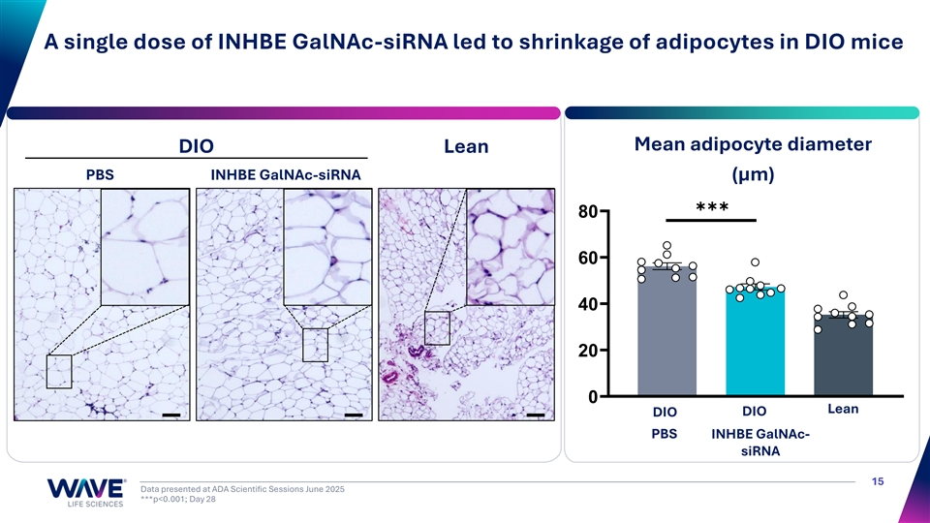
A single dose of INHBE GalNAc-siRNA led to shrinkage of adipocytes in DIO mice Mean adipocyte diameter DIO Lean PBS INHBE GalNAc-siRNA (μm) ✱✱✱ 80 60 40 20 0 Lean DIO DIO PBS INHBE GalNAc- siRNA 15 Data presented at ADA Scientific Sessions June 2025 ***p<0.001; Day 28

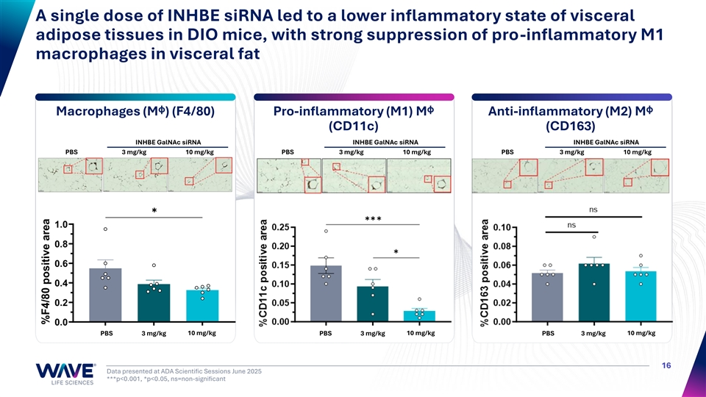
A single dose of INHBE siRNA led to a lower inflammatory state of visceral adipose tissues in DIO mice, with strong suppression of pro-inflammatory M1 macrophages in visceral fat Macrophages (Mᶲ) (F4/80) Pro-inflammatory (M1) Mᶲ Anti-inflammatory (M2) Mᶲ (CD11c) (CD163) INHBE GalNAc siRNA INHBE GalNAc siRNA INHBE GalNAc siRNA PBS 3 mg/kg 10 mg/kg PBS 3 mg/kg 10 mg/kg PBS 3 mg/kg 10 mg/kg ✱ 1.0 0.8 0.6 0.4 0.2 0.0 PBS 3 mg/kg 10 mg/kg PBS 3 mg/kg 10 mg/kg PBS 3 mg/kg 10 mg/kg 16 Data presented at ADA Scientific Sessions June 2025 ***p<0.001, *p<0.05, ns=non-significant %F4/80 positive area

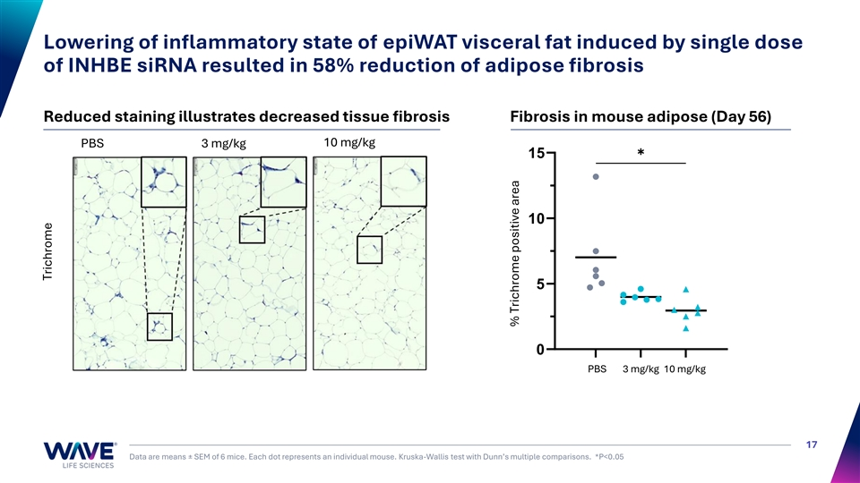
Lowering of inflammatory state of epiWAT visceral fat induced by single dose of INHBE siRNA resulted in 58% reduction of adipose fibrosis Reduced staining illustrates decreased tissue fibrosis Fibrosis in mouse adipose (Day 56) 10 mg/kg PBS 3 mg/kg ✱ 15 10 5 0 PBS 3 mg/kg 10 mg/kg 17 Data are means ± SEM of 6 mice. Each dot represents an individual mouse. Kruska-Wallis test with Dunn’s multiple comparisons. *P<0.05 Trichrome % Trichrome positive area

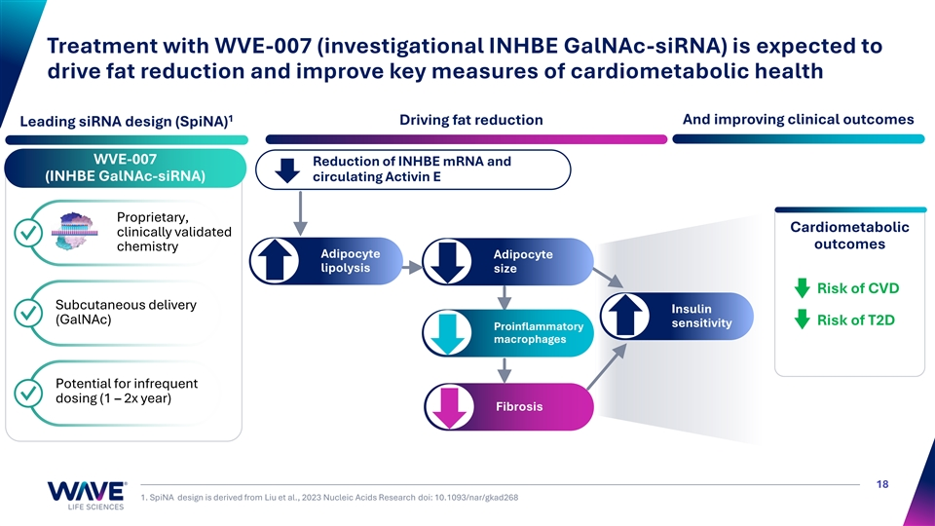
Treatment with WVE-007 (investigational INHBE GalNAc-siRNA) is expected to drive fat reduction and improve key measures of cardiometabolic health 1 Driving fat reduction And improving clinical outcomes Leading siRNA design (SpiNA) WVE-007 Reduction of INHBE mRNA and (INHBE GalNAc-siRNA) circulating Activin E Proprietary, Cardiometabolic clinically validated ✓ outcomes chemistry Adipocyte Adipocyte lipolysis size Risk of CVD Subcutaneous delivery Insulin ✓ (GalNAc) Risk of T2D sensitivity Proinflammatory macrophages Potential for infrequent ✓ dosing (1 – 2x year) Fibrosis 18 1. SpiNA design is derived from Liu et al., 2023 Nucleic Acids Research doi: 10.1093/nar/gkad268

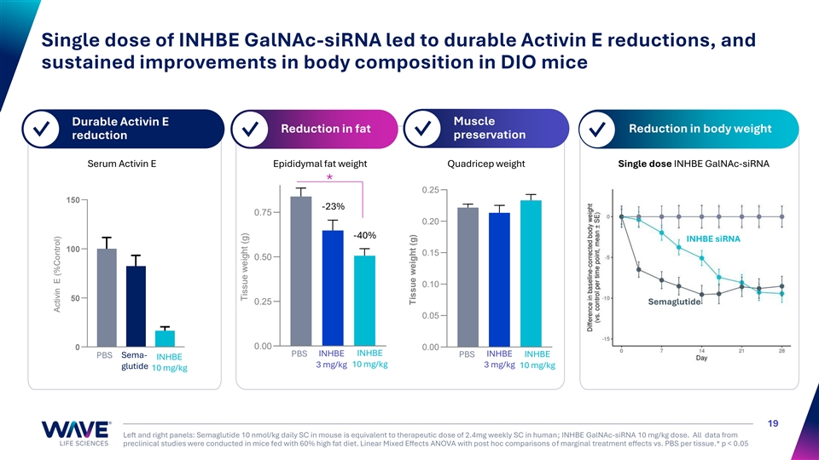
Single dose of INHBE GalNAc-siRNA led to durable Activin E reductions, and sustained improvements in body composition in DIO mice Muscle Durable Activin E Reduction in fat Reduction in body weight ✓ ✓ ✓ preservation ✓ reduction Serum Activin E Epididymal fat weight Quadricep weight Single dose INHBE GalNAc-siRNA * 0.25 150 -23% 0.75 0.20 -40% INHBE siRNA 100 0.15 0.50 0.10 50 0.25 Semaglutide 0.05 0 0.00 0.00 PBS INHBE INHBE INHBE PBS Sema- PBS INHBE INHBE 10 mg/kg 3 mg/kg 3 mg/kg 10 mg/kg glutide 10 mg/kg 19 Left and right panels: Semaglutide 10 nmol/kg daily SC in mouse is equivalent to therapeutic dose of 2.4mg weekly SC in human; INHBE GalNAc-siRNA 10 mg/kg dose. All data from preclinical studies were conducted in mice fed with 60% high fat diet. Linear Mixed Effects ANOVA with post hoc comparisons of marginal treatment effects vs. PBS per tissue.* p < 0.05 Activin E (%Control) Tissue weight (g) Tissue weight (g)

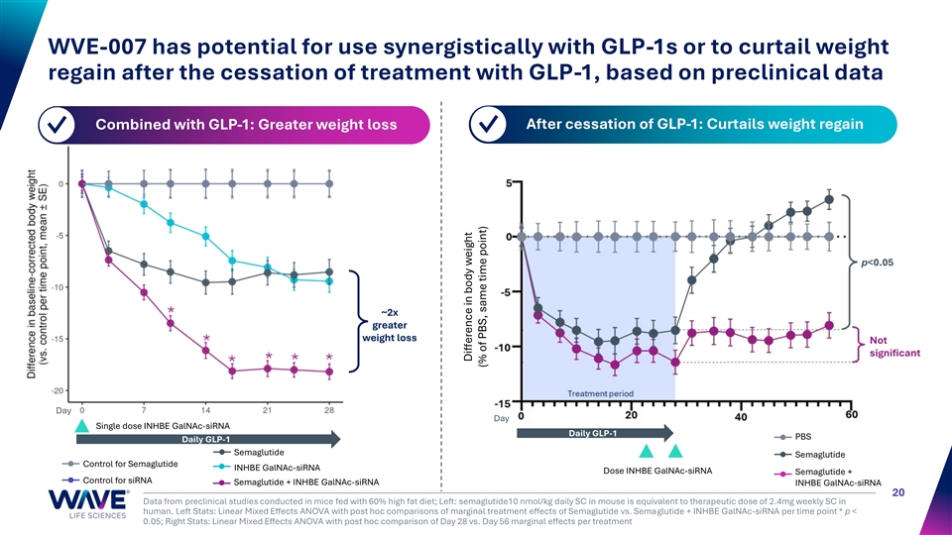
WVE-007 has potential for use synergistically with GLP-1s or to curtail weight regain after the cessation of treatment with GLP-1, based on preclinical data Combined with GLP-1: Greater weight loss After cessation of GLP-1: Curtails weight regain ✓ ✓ p<0.05 ~2x greater weight loss Not significant Day Day Single dose INHBE GalNAc-siRNA Daily GLP-1 PBS Daily GLP-1 Semaglutide Semaglutide Control for Semaglutide INHBE GalNAc-siRNA Dose INHBE GalNAc-siRNA Semaglutide + Control for siRNA Semaglutide + INHBE GalNAc-siRNA INHBE GalNAc-siRNA 20 Data from preclinical studies conducted in mice fed with 60% high fat diet; Left: semaglutide10 nmol/kg daily SC in mouse is equivalent to therapeutic dose of 2.4mg weekly SC in human. Left Stats: Linear Mixed Effects ANOVA with post hoc comparisons of marginal treatment effects of Semaglutide vs. Semaglutide + INHBE GalNAc-siRNA per time point * p < 0.05; Right Stats: Linear Mixed Effects ANOVA with post hoc comparison of Day 28 vs. Day 56 marginal effects per treatment Difference in body weight (% of PBS, same time point)

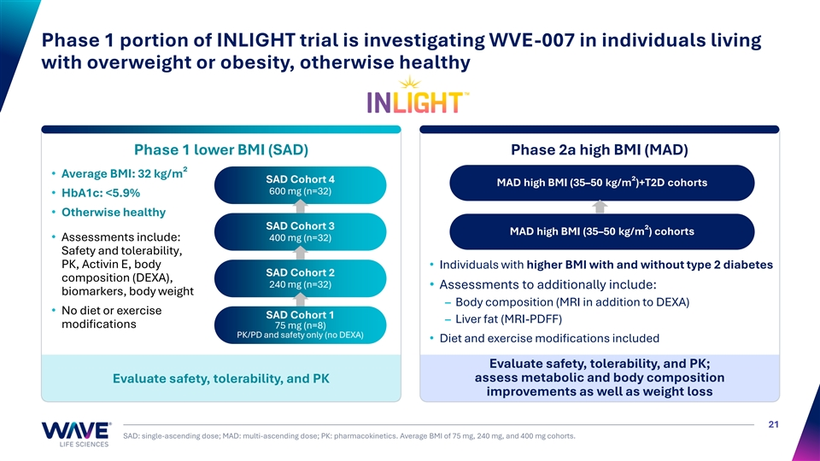
Phase 1 portion of INLIGHT trial is investigating WVE-007 in individuals living with overweight or obesity, otherwise healthy Phase 1 lower BMI (SAD) Phase 2a high BMI (MAD) • Average BMI: 32 kg/m² SAD Cohort 4 MAD high BMI (35–50 kg/m²)+T2D cohorts 600 mg (n=32) • HbA1c: <5.9% • Otherwise healthy SAD Cohort 3 MAD high BMI (35–50 kg/m²) cohorts • Assessments include: 400 mg (n=32) Safety and tolerability, PK, Activin E, body • Individuals with higher BMI with and without type 2 diabetes SAD Cohort 2 composition (DEXA), 240 mg (n=32) • Assessments to additionally include: biomarkers, body weight – Body composition (MRI in addition to DEXA) • No diet or exercise SAD Cohort 1 – Liver fat (MRI-PDFF) modifications 75 mg (n=8) PK/PD and safety only (no DEXA) • Diet and exercise modifications included Evaluate safety, tolerability, and PK; assess metabolic and body composition Evaluate safety, tolerability, and PK improvements as well as weight loss 21 SAD: single-ascending dose; MAD: multi-ascending dose; PK: pharmacokinetics. Average BMI of 75 mg, 240 mg, and 400 mg cohorts.

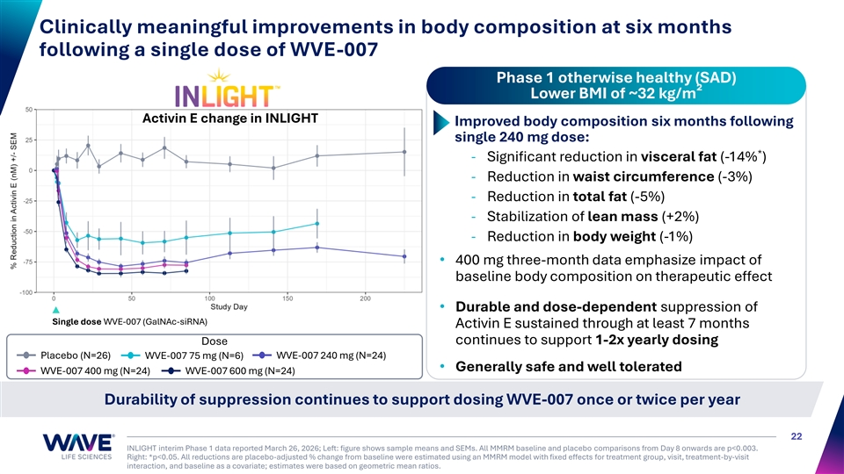
Clinically meaningful improvements in body composition at six months following a single dose of WVE-007 Phase 1 otherwise healthy (SAD) Lower BMI of ~32 kg/m² Activin E change in INLIGHT Improved body composition six months following single 240 mg dose: * - Significant reduction in visceral fat (-14% ) - Reduction in waist circumference (-3%) - Reduction in total fat (-5%) - Stabilization of lean mass (+2%) - Reduction in body weight (-1%) • 400 mg three-month data emphasize impact of baseline body composition on therapeutic effect • Durable and dose-dependent suppression of Single dose WVE-007 (GalNAc-siRNA) Activin E sustained through at least 7 months continues to support 1-2x yearly dosing Dose Placebo (N=26) WVE-007 75 mg (N=6) WVE-007 240 mg (N=24) • Generally safe and well tolerated WVE-007 400 mg (N=24) WVE-007 600 mg (N=24) Durability of suppression continues to support dosing WVE-007 once or twice per year 22 INLIGHT interim Phase 1 data reported March 26, 2026; Left: figure shows sample means and SEMs. All MMRM baseline and placebo comparisons from Day 8 onwards are p<0.003. Right: *p<0.05. All reductions are placebo-adjusted % change from baseline were estimated using an MMRM model with fixed effects for treatment group, visit, treatment-by-visit interaction, and baseline as a covariate; estimates were based on geometric mean ratios.

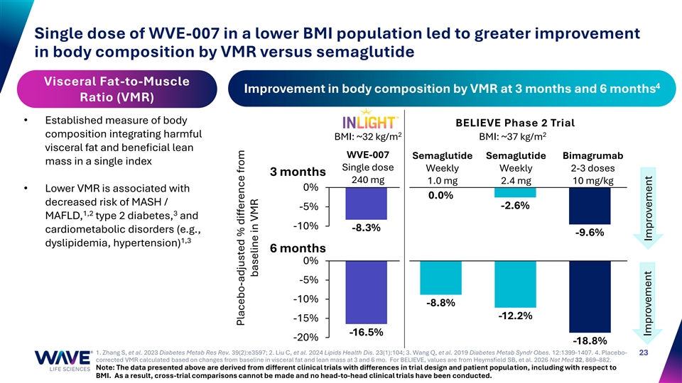
Single dose of WVE-007 in a lower BMI population led to greater improvement in body composition by VMR versus semaglutide Visceral Fat-to-Muscle 4 Improvement in body composition by VMR at 3 months and 6 months Ratio (VMR) • Established measure of body BELIEVE Phase 2 Trial 2 2 composition integrating harmful BMI: ~32 kg/m BMI: ~37 kg/m visceral fat and beneficial lean WVE-007 Semaglutide Semaglutide Bimagrumab mass in a single index Single dose Weekly Weekly 2-3 doses 3 months 240 mg 1.0 mg 2.4 mg 10 mg/kg 0% • Lower VMR is associated with 0.0% decreased risk of MASH / -2.6% -5% 1,2 3 MAFLD, type 2 diabetes, and -10% -8.3% cardiometabolic disorders (e.g., -9.6% 1,3 dyslipidemia, hypertension) 6 months 0% -5% -10% -8.8% -12.2% -15% -16.5% -20% -18.8% 1. Zhang S, et al. 2023 Diabetes Metab Res Rev. 39(2):e3597; 2. Liu C, et al. 2024 Lipids Health Dis. 23(1):104; 3. Wang Q, et al. 2019 Diabetes Metab Syndr Obes. 12:1399-1407. 4. Placebo- 23 corrected VMR calculated based on changes from baseline in visceral fat and lean mass at 3 and 6 mo. For BELIEVE, values are from Heymsfield SB, et al. 2026 Nat Med 32, 869–882. Note: The data presented above are derived from different clinical trials with differences in trial design and patient population, including with respect to BMI. As a result, cross-trial comparisons cannot be made and no head-to-head clinical trials have been conducted. Placebo-adjusted % difference from baseline in VMR Improvement Improvement

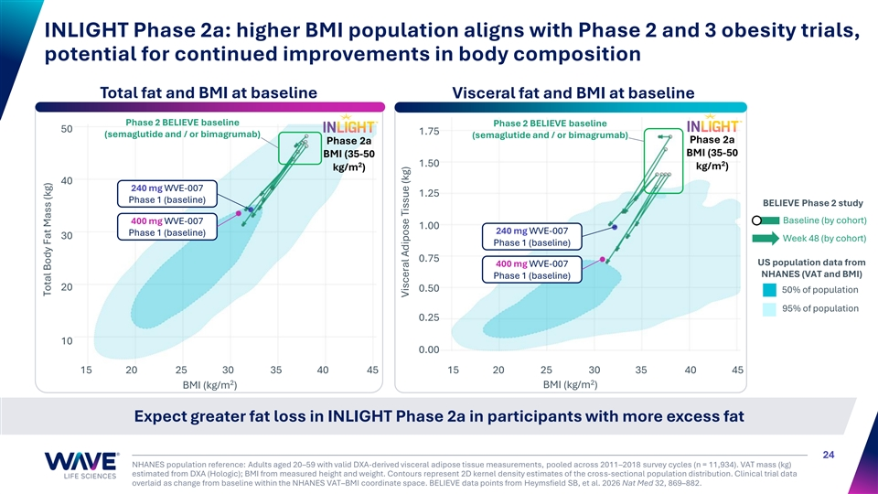
INLIGHT Phase 2a: higher BMI population aligns with Phase 2 and 3 obesity trials, potential for continued improvements in body composition Total fat and BMI at baseline Visceral fat and BMI at baseline Phase 2 BELIEVE baseline Phase 2 BELIEVE baseline 50 1.75 (semaglutide and / or bimagrumab) (semaglutide and / or bimagrumab) Phase 2a Phase 2a BMI (35-50 BMI (35-50 2 2 1.50 kg/m ) kg/m ) 40 240 mg WVE-007 1.25 Phase 1 (baseline) BELIEVE Phase 2 study Baseline (by cohort) 400 mg WVE-007 1.00 240 mg WVE-007 Phase 1 (baseline) 30 Week 48 (by cohort) Phase 1 (baseline) 0.75 US population data from 400 mg WVE-007 NHANES (VAT and BMI) Phase 1 (baseline) 20 0.50 50% of population 95% of population 0.25 10 0.00 15 20 25 30 35 40 45 15 20 25 30 35 40 45 2 2 BMI (kg/m ) BMI (kg/m ) Expect greater fat loss in INLIGHT Phase 2a in participants with more excess fat 24 NHANES population reference: Adults aged 20–59 with valid DXA-derived visceral adipose tissue measurements, pooled across 2011–2018 survey cycles (n = 11,934). VAT mass (kg) estimated from DXA (Hologic); BMI from measured height and weight. Contours represent 2D kernel density estimates of the cross-sectional population distribution. Clinical trial data overlaid as change from baseline within the NHANES VAT–BMI coordinate space. BELIEVE data points from Heymsfield SB, et al. 2026 Nat Med 32, 869–882. Total Body Fat Mass (kg) Visceral Adipose Tissue (kg)

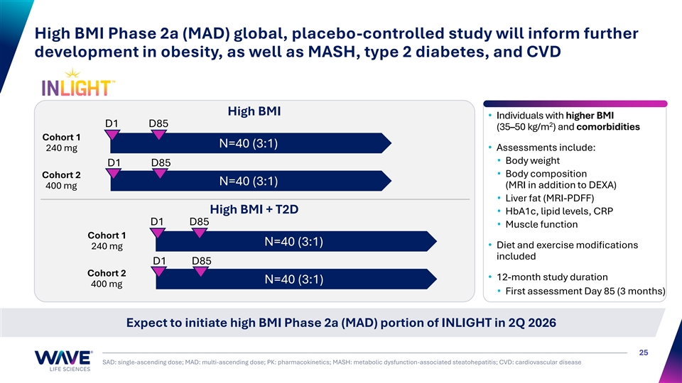
High BMI Phase 2a (MAD) global, placebo-controlled study will inform further development in obesity, as well as MASH, type 2 diabetes, and CVD High BMI • Individuals with higher BMI 2 D1 D85 (35–50 kg/m ) and comorbidities Cohort 1 N=40 (3:1) 240 mg• Assessments include: • Body weight D1 D85 • Body composition Cohort 2 N=40 (3:1) (MRI in addition to DEXA) 400 mg • Liver fat (MRI-PDFF) High BMI + T2D • HbA1c, lipid levels, CRP D1 D85 • Muscle function Cohort 1 N=40 (3:1) • Diet and exercise modifications 240 mg included D1 D85 Cohort 2 • 12-month study duration N=40 (3:1) 400 mg • First assessment Day 85 (3 months) Expect to initiate high BMI Phase 2a (MAD) portion of INLIGHT in 2Q 2026 25 SAD: single-ascending dose; MAD: multi-ascending dose; PK: pharmacokinetics; MASH: metabolic dysfunction-associated steatohepatitis; CVD: cardiovascular disease

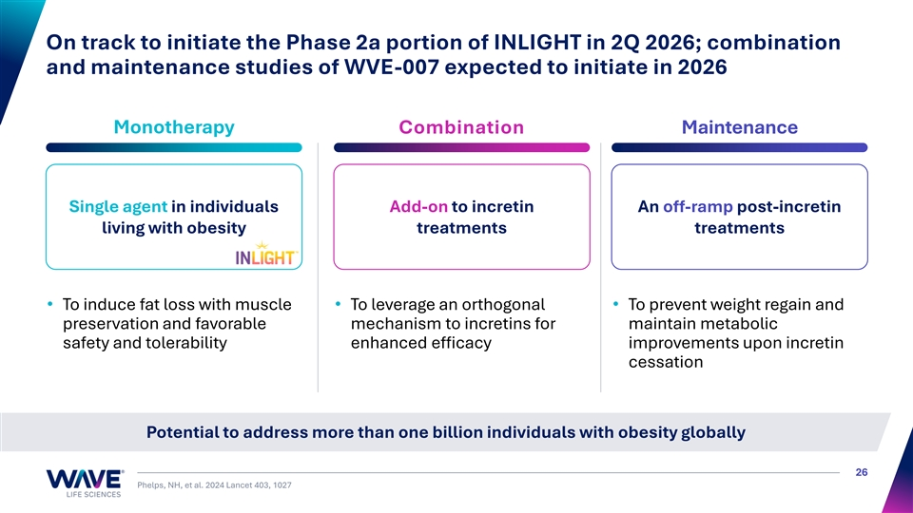
On track to initiate the Phase 2a portion of INLIGHT in 2Q 2026; combination and maintenance studies of WVE-007 expected to initiate in 2026 Monotherapy Combination Maintenance Single agent in individuals Add-on to incretin An off-ramp post-incretin living with obesity treatments treatments • To induce fat loss with muscle • To leverage an orthogonal • To prevent weight regain and preservation and favorable mechanism to incretins for maintain metabolic safety and tolerability enhanced efficacy improvements upon incretin cessation Potential to address more than one billion individuals with obesity globally 26 Phelps, NH, et al. 2024 Lancet 403, 1027

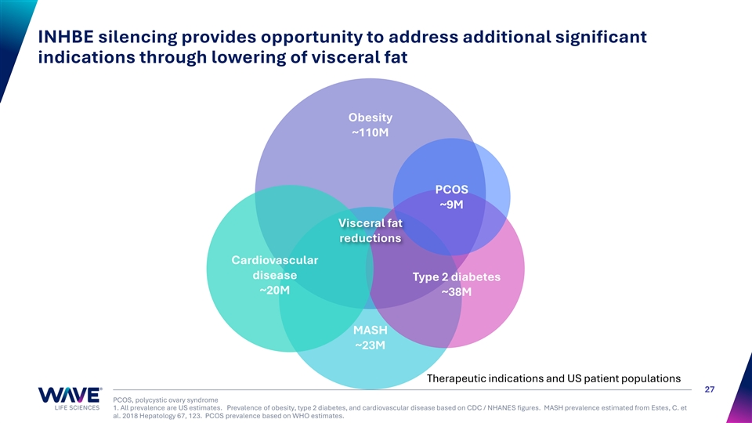
INHBE silencing provides opportunity to address additional significant indications through lowering of visceral fat Obesity ~110M PCOS ~9M Visceral fat reductions Cardiovascular disease Type 2 diabetes ~20M ~38M MASH ~23M Therapeutic indications and US patient populations 27 PCOS, polycystic ovary syndrome 1. All prevalence are US estimates. Prevalence of obesity, type 2 diabetes, and cardiovascular disease based on CDC / NHANES figures. MASH prevalence estimated from Estes, C. et al. 2018 Hepatology 67, 123. PCOS prevalence based on WHO estimates.

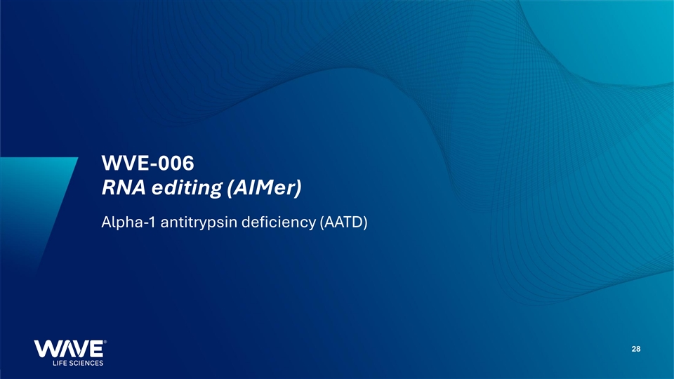
WVE-006 RNA editing (AIMer) Alpha-1 antitrypsin deficiency (AATD) 28

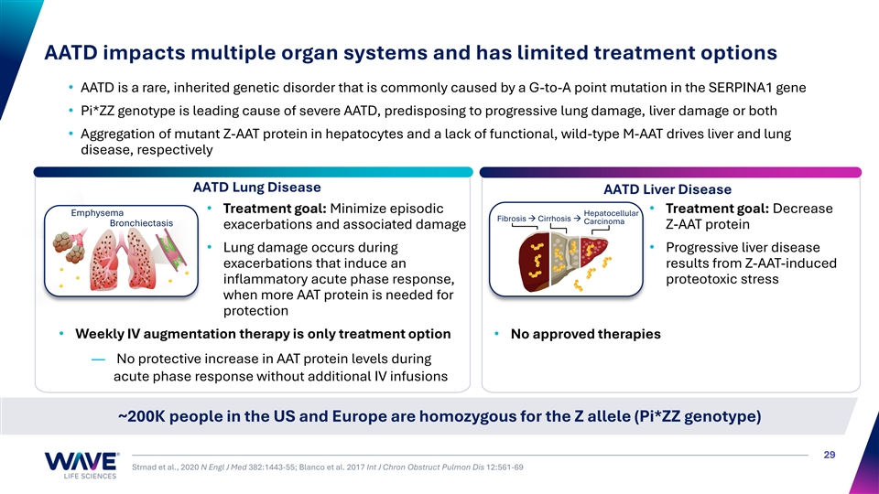
AATD impacts multiple organ systems and has limited treatment options • AATD is a rare, inherited genetic disorder that is commonly caused by a G-to-A point mutation in the SERPINA1 gene • Pi*ZZ genotype is leading cause of severe AATD, predisposing to progressive lung damage, liver damage or both • Aggregation of mutant Z-AAT protein in hepatocytes and a lack of functional, wild-type M-AAT drives liver and lung disease, respectively AATD Lung Disease AATD Liver Disease • Treatment goal: Minimize episodic • Treatment goal: Decrease Emphysema Hepatocellular Fibrosis → Cirrhosis → Carcinoma Bronchiectasis exacerbations and associated damage Z-AAT protein • Lung damage occurs during • Progressive liver disease exacerbations that induce an results from Z-AAT-induced inflammatory acute phase response, proteotoxic stress when more AAT protein is needed for protection • Weekly IV augmentation therapy is only treatment option• No approved therapies — No protective increase in AAT protein levels during acute phase response without additional IV infusions ~200K people in the US and Europe are homozygous for the Z allele (Pi*ZZ genotype) 29 Strnad et al., 2020 N Engl J Med 382:1443-55; Blanco et al. 2017 Int J Chron Obstruct Pulmon Dis 12:561-69

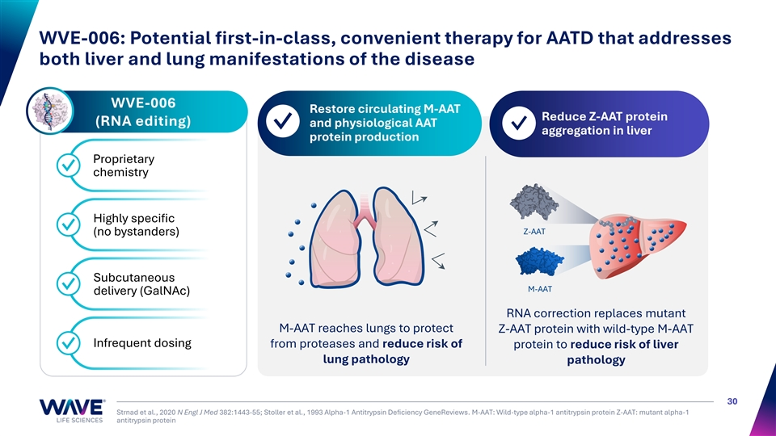
WVE-006: Potential first-in-class, convenient therapy for AATD that addresses both liver and lung manifestations of the disease WVE-006 Restore circulating M-AAT 1 2 Reduce Z-AAT protein (RNA editing) and physiological AAT ✓ ✓ aggregation in liver protein production Proprietary ✓ chemistry Highly specific ✓ Z-AAT (no bystanders) Subcutaneous ✓ M-AAT delivery (GalNAc) RNA correction replaces mutant M-AAT reaches lungs to protect Z-AAT protein with wild-type M-AAT Infrequent dosing from proteases and reduce risk of protein to reduce risk of liver ✓ lung pathology pathology 30 Strnad et al., 2020 N Engl J Med 382:1443-55; Stoller et al., 1993 Alpha-1 Antitrypsin Deficiency GeneReviews. M-AAT: Wild-type alpha-1 antitrypsin protein Z-AAT: mutant alpha-1 antitrypsin protein

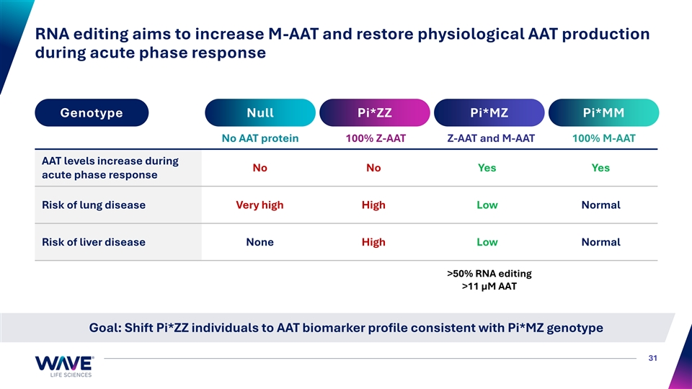
RNA editing aims to increase M-AAT and restore physiological AAT production during acute phase response Genotype Null Pi*ZZ Pi*MZ Pi*MM No AAT protein 100% Z-AAT Z-AAT and M-AAT 100% M-AAT AAT levels increase during No No Yes Yes acute phase response Risk of lung disease Very high High Low Normal Risk of liver disease None High Low Normal >50% RNA editing >11 µM AAT Goal: Shift Pi*ZZ individuals to AAT biomarker profile consistent with Pi*MZ genotype 31

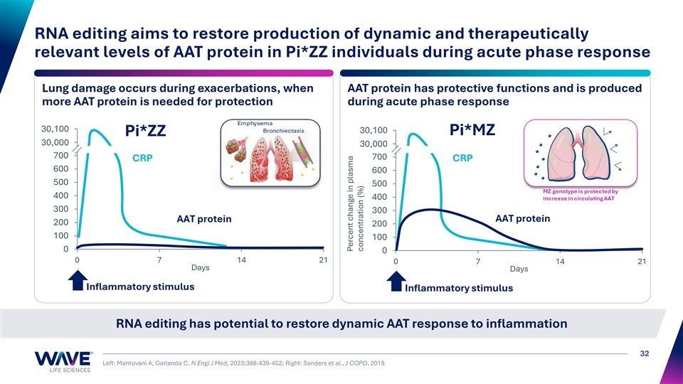
RNA editing aims to restore production of dynamic and therapeutically relevant levels of AAT protein in Pi*ZZ individuals during acute phase response Lung damage occurs during exacerbations, when AAT protein has protective functions and is produced more AAT protein is needed for protection during acute phase response 30,9 10 00 0 900 30,100 Pi*MZ Pi*ZZ 30,8 00 00 0 30,8 00 00 0 700 700 CRP CRP 600 600 500 500 400 400 300 300 AAT protein AAT protein 200 200 100 100 0 0 0 7 14 21 0 7 14 21 Days Days Inflammatory stimulus Inflammatory stimulus RNA editing has potential to restore dynamic AAT response to inflammation 32 Left: Mantovani A, Garlanda C. N Engl J Med, 2023;388:439-452; Right: Sanders et al., J COPD, 2018 Percent change in plasma concentration (%)

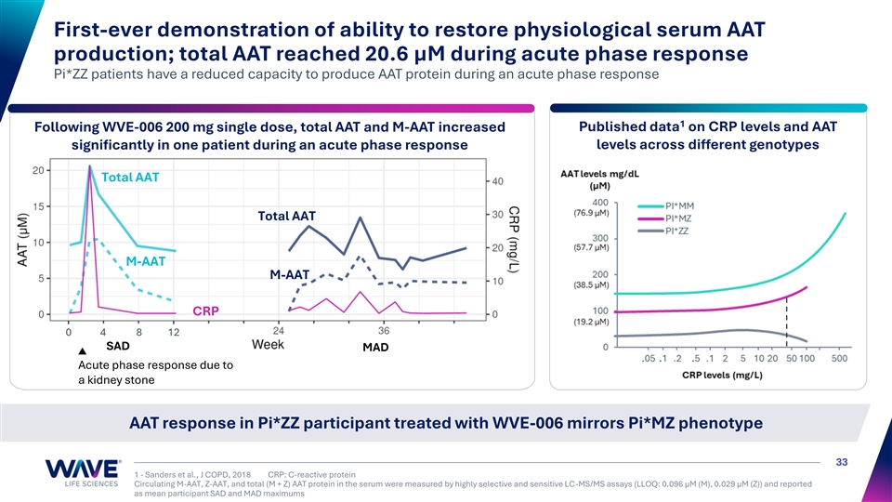
First-ever demonstration of ability to restore physiological serum AAT production; total AAT reached 20.6 µM during acute phase response Pi*ZZ patients have a reduced capacity to produce AAT protein during an acute phase response 1 Following WVE-006 200 mg single dose, total AAT and M-AAT increased Published data on CRP levels and AAT levels across different genotypes significantly in one patient during an acute phase response Total AAT Total AAT M-AAT M-AAT CRP 0 4 8 12 SAD MAD Acute phase response due to a kidney stone AAT response in Pi*ZZ participant treated with WVE-006 mirrors Pi*MZ phenotype 33 1 - Sanders et al., J COPD, 2018 CRP: C-reactive protein Circulating M-AAT, Z-AAT, and total (M + Z) AAT protein in the serum were measured by highly selective and sensitive LC-MS/MS assays (LLOQ: 0.096 µM (M), 0.029 µM (Z)) and reported as mean participant SAD and MAD maximums M-AAT + Z-AAT (µM) CRP levels (mg/L)

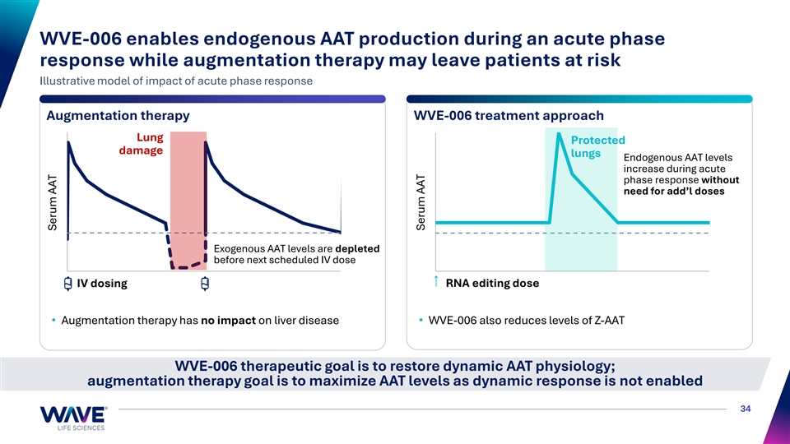
WVE-006 enables endogenous AAT production during an acute phase response while augmentation therapy may leave patients at risk Illustrative model of impact of acute phase response Augmentation therapy WVE-006 treatment approach Lung Protected damage lungs Endogenous AAT levels increase during acute phase response without need for add’l doses Exogenous AAT levels are depleted before next scheduled IV dose IV dosing RNA editing dose • Augmentation therapy has no impact on liver disease• WVE-006 also reduces levels of Z-AAT WVE-006 therapeutic goal is to restore dynamic AAT physiology; augmentation therapy goal is to maximize AAT levels as dynamic response is not enabled 34 Serum AAT Serum AAT

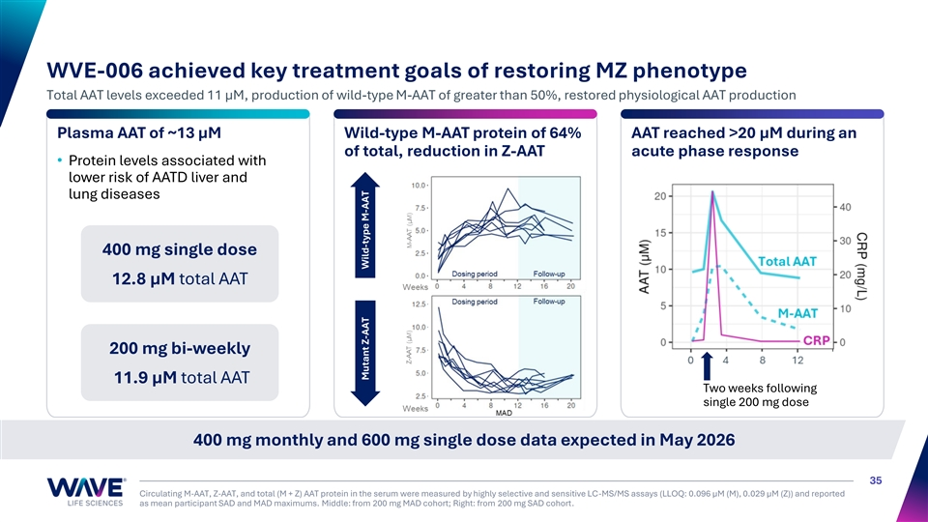
CRP (mg/L) WVE-006 achieved key treatment goals of restoring MZ phenotype Total AAT levels exceeded 11 µM, production of wild-type M-AAT of greater than 50%, restored physiological AAT production Plasma AAT of ~13 µM Wild-type M-AAT protein of 64% AAT reached >20 μM during an of total, reduction in Z-AAT acute phase response • Protein levels associated with lower risk of AATD liver and lung diseases 400 mg single dose 12.8 µM total AAT 200 mg bi-weekly 11.9 µM total AAT Two weeks following single 200 mg dose 400 mg monthly and 600 mg single dose data expected in May 2026 35 Circulating M-AAT, Z-AAT, and total (M + Z) AAT protein in the serum were measured by highly selective and sensitive LC-MS/MS assays (LLOQ: 0.096 µM (M), 0.029 µM (Z)) and reported as mean participant SAD and MAD maximums. Middle: from 200 mg MAD cohort; Right: from 200 mg SAD cohort. Mutant Z-AAT Wild-type M-AAT

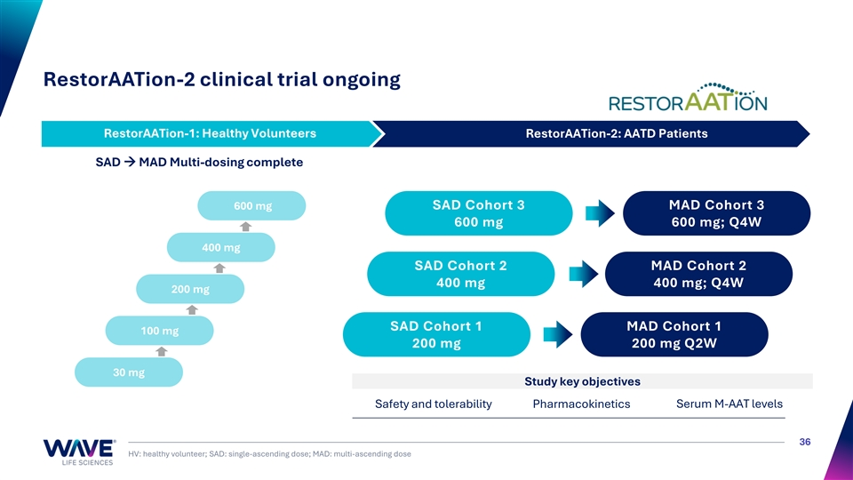
RestorAATion-2 clinical trial ongoing RestorAATion-1: Healthy Volunteers RestorAATion-2: AATD Patients RestorAATion-1: Healthy Volunteers SAD → MAD Multi-dosing complete 600 mg SAD Cohort 3 MAD Cohort 3 600 mg 600 mg; Q4W 400 mg SAD Cohort 2 MAD Cohort 2 400 mg 400 mg; Q4W 200 mg SAD Cohort 1 MAD Cohort 1 100 mg 200 mg 200 mg Q2W 30 mg Study key objectives Safety and tolerability Pharmacokinetics Serum M-AAT levels 36 HV: healthy volunteer; SAD: single-ascending dose; MAD: multi-ascending dose


WVE-008 RNA editing (AIMer) PNPLA3 I148M liver disease 37

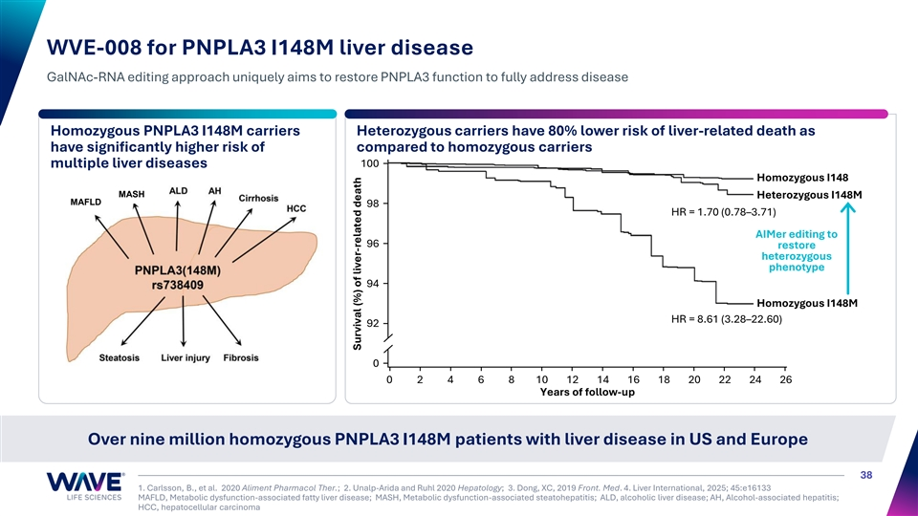
WVE-008 for PNPLA3 I148M liver disease GalNAc-RNA editing approach uniquely aims to restore PNPLA3 function to fully address disease Homozygous PNPLA3 I148M carriers Heterozygous carriers have 80% lower risk of liver-related death as have significantly higher risk of compared to homozygous carriers 100 multiple liver diseases Homozygous I148 MASH Heterozygous I148M MAFLD 98 HR = 1.70 (0.78–3.71) AIMer editing to 96 restore heterozygous phenotype 94 Homozygous I148M HR = 8.61 (3.28–22.60) 92 0 0 2 4 6 8 10 12 14 16 18 20 22 24 26 Years of follow-up Over nine million homozygous PNPLA3 I148M patients with liver disease in US and Europe 38 1. Carlsson, B., et al. 2020 Aliment Pharmacol Ther.; 2. Unalp-Arida and Ruhl 2020 Hepatology; 3. Dong, XC, 2019 Front. Med. 4. Liver International, 2025; 45:e16133 MAFLD, Metabolic dysfunction-associated fatty liver disease; MASH, Metabolic dysfunction-associated steatohepatitis; ALD, alcoholic liver disease; AH, Alcohol-associated hepatitis; HCC, hepatocellular carcinoma Survival (%) of liver-related death

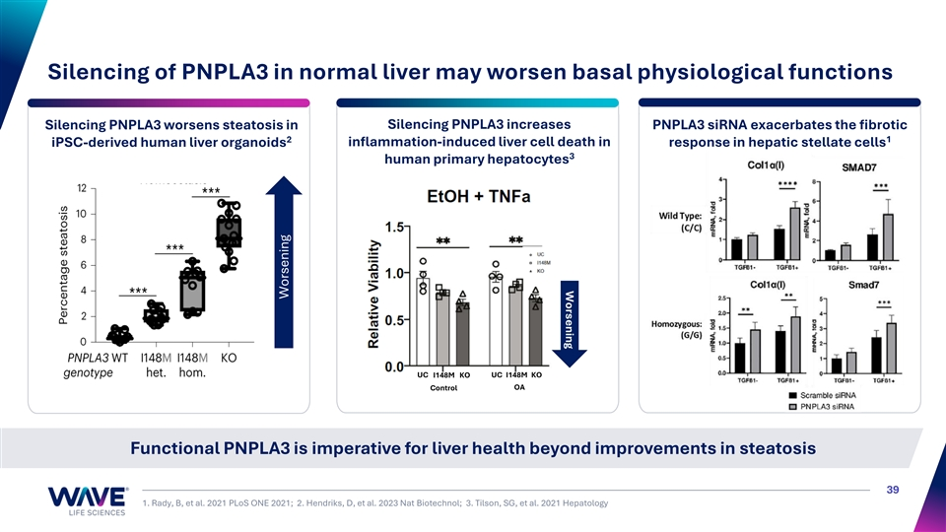
Worsening Silencing of PNPLA3 in normal liver may worsen basal physiological functions Silencing PNPLA3 increases Silencing PNPLA3 worsens steatosis in PNPLA3 siRNA exacerbates the fibrotic 1 2 iPSC-derived human liver organoids inflammation-induced liver cell death in response in hepatic stellate cells 3 human primary hepatocytes UC I148M KO UC I148M KO Control OA Functional PNPLA3 is imperative for liver health beyond improvements in steatosis 39 1. Rady, B, et al. 2021 PLoS ONE 2021; 2. Hendriks, D, et al. 2023 Nat Biotechnol; 3. Tilson, SG, et al. 2021 Hepatology Worsening

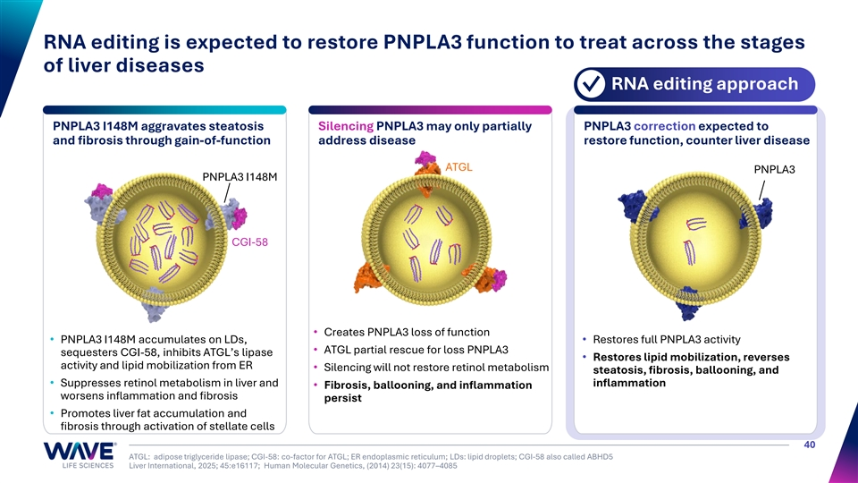
RNA editing is expected to restore PNPLA3 function to treat across the stages of liver diseases RNA editing approach ✓ PNPLA3 I148M aggravates steatosis Silencing PNPLA3 may only partially PNPLA3 correction expected to and fibrosis through gain-of-function address disease restore function, counter liver disease ATGL PNPLA3 PNPLA3 I148M CGI-58 • Creates PNPLA3 loss of function • PNPLA3 I148M accumulates on LDs, • Restores full PNPLA3 activity • ATGL partial rescue for loss PNPLA3 sequesters CGI-58, inhibits ATGL’s lipase • Restores lipid mobilization, reverses activity and lipid mobilization from ER • Silencing will not restore retinol metabolism steatosis, fibrosis, ballooning, and • Suppresses retinol metabolism in liver and inflammation • Fibrosis, ballooning, and inflammation worsens inflammation and fibrosis persist • Promotes liver fat accumulation and fibrosis through activation of stellate cells 40 ATGL: adipose triglyceride lipase; CGI-58: co-factor for ATGL; ER endoplasmic reticulum; LDs: lipid droplets; CGI-58 also called ABHD5 Liver International, 2025; 45:e16117; Human Molecular Genetics, (2014) 23(15): 4077–4085

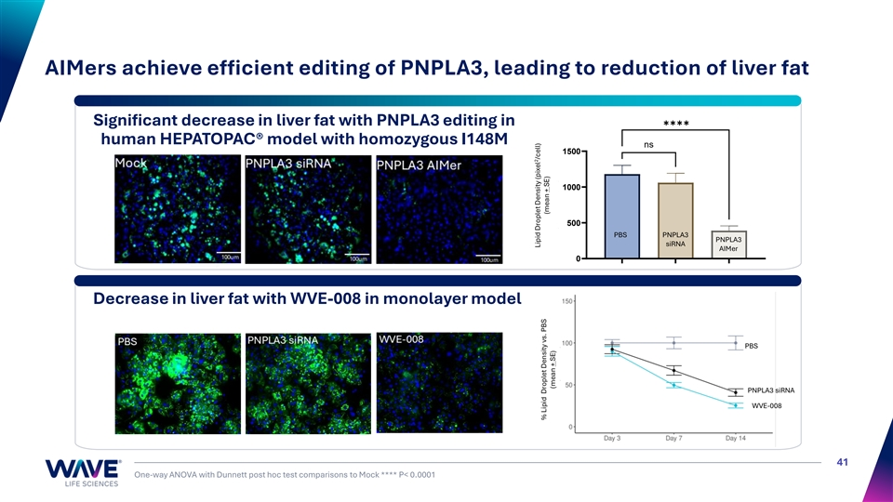
AIMers achieve efficient editing of PNPLA3, leading to reduction of liver fat ✱✱✱✱ Significant decrease in liver fat with PNPLA3 editing in human HEPATOPAC® model with homozygous I148M ns 1500 1000 500 PBS PNPLA3 PNPLA3 siRNA AIMer 0 Decrease in liver fat with WVE-008 in monolayer model PNPLA3 siRNA PBS PNPLA3 siRNA WVE-008 41 One-way ANOVA with Dunnett post hoc test comparisons to Mock **** P< 0.0001 Mock PNPLA3 siRNA PNPLA3 AIMer 2 Lipid Droplet Density (pixel /cell) 2 Lipid Droplet Density (pixel /cell) % Lipid Droplet Density vs. PBS (mean + SE) (mean + SE) (mean ± SE)

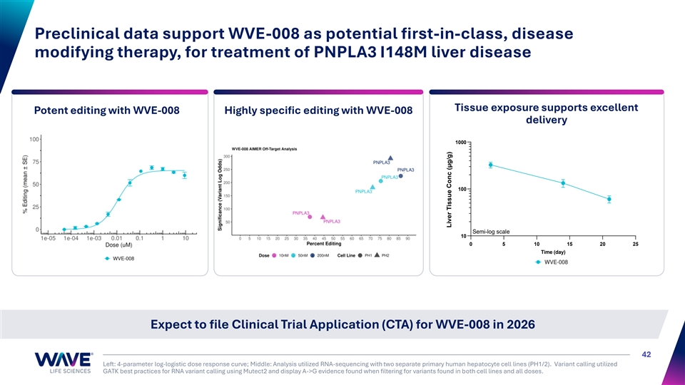
Preclinical data support WVE-008 as potential first-in-class, disease modifying therapy, for treatment of PNPLA3 I148M liver disease Tissue exposure supports excellent Potent editing with WVE-008 Highly specific editing with WVE-008 delivery 1000 100 Semi-log scale 10 0 5 10 15 20 25 Time (day) Expect to file Clinical Trial Application (CTA) for WVE-008 in 2026 42 Left: 4-parameter log-logistic dose response curve; Middle: Analysis utilized RNA-sequencing with two separate primary human hepatocyte cell lines (PH1/2). Variant calling utilized GATK best practices for RNA variant calling using Mutect2 and display A->G evidence found when filtering for variants found in both cell lines and all doses. Liver Tissue Conc (μg/g)


Bifunctional modalities Single oligonucleotide constructs 43

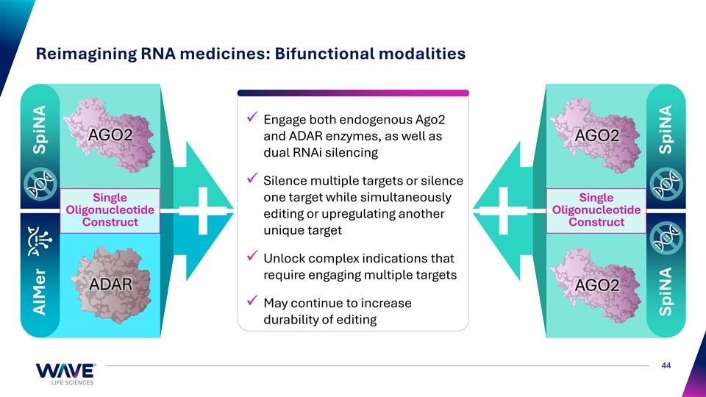
Reimagining RNA medicines: Bifunctional modalities ✓ Engage both endogenous Ago2 AGO2 and ADAR enzymes, as well as AGO2 dual RNAi silencing ✓ Silence multiple targets or silence Single one target while simultaneously Single Oligonucleotide Oligonucleotide editing or upregulating another Construct Construct unique target ✓ Unlock complex indications that require engaging multiple targets ADAR AGO2 ✓ May continue to increase durability of editing 44 AIMer SpiNA SpiNA SpiNA


Other clinical programs Duchenne muscular dystrophy 45

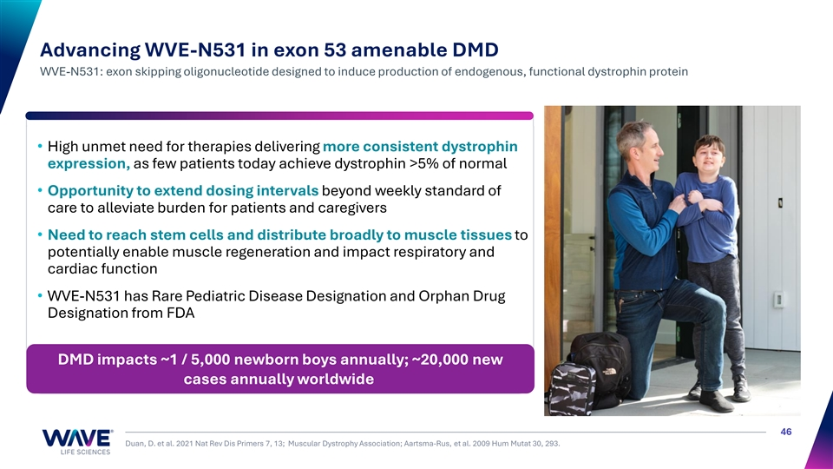
Advancing WVE-N531 in exon 53 amenable DMD WVE-N531: exon skipping oligonucleotide designed to induce production of endogenous, functional dystrophin protein • High unmet need for therapies delivering more consistent dystrophin expression, as few patients today achieve dystrophin >5% of normal • Opportunity to extend dosing intervals beyond weekly standard of care to alleviate burden for patients and caregivers • Need to reach stem cells and distribute broadly to muscle tissues to potentially enable muscle regeneration and impact respiratory and cardiac function • WVE-N531 has Rare Pediatric Disease Designation and Orphan Drug Designation from FDA DMD impacts ~1 / 5,000 newborn boys annually; ~20,000 new cases annually worldwide 46 Duan, D. et al. 2021 Nat Rev Dis Primers 7, 13; Muscular Dystrophy Association; Aartsma-Rus, et al. 2009 Hum Mutat 30, 293.

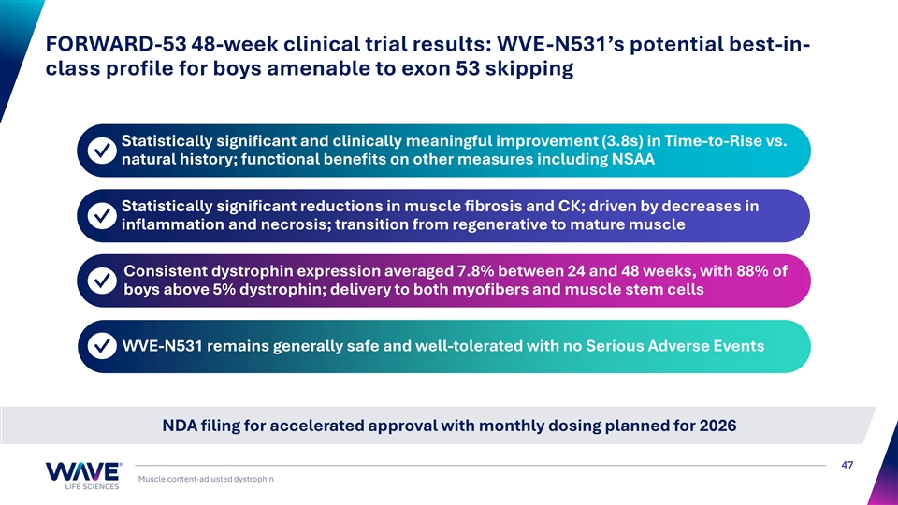
FORWARD-53 48-week clinical trial results: WVE-N531’s potential best-in- class profile for boys amenable to exon 53 skipping Statistically significant and clinically meaningful improvement (3.8s) in Time-to-Rise vs. ✓ natural history; functional benefits on other measures including NSAA Statistically significant reductions in muscle fibrosis and CK; driven by decreases in ✓ inflammation and necrosis; transition from regenerative to mature muscle Consistent dystrophin expression averaged 7.8% between 24 and 48 weeks, with 88% of ✓ boys above 5% dystrophin; delivery to both myofibers and muscle stem cells WVE-N531 remains generally safe and well-tolerated with no Serious Adverse Events ✓ NDA filing for accelerated approval with monthly dosing planned for 2026 47 Muscle content-adjusted dystrophin


Reimagining RNA medicines 48

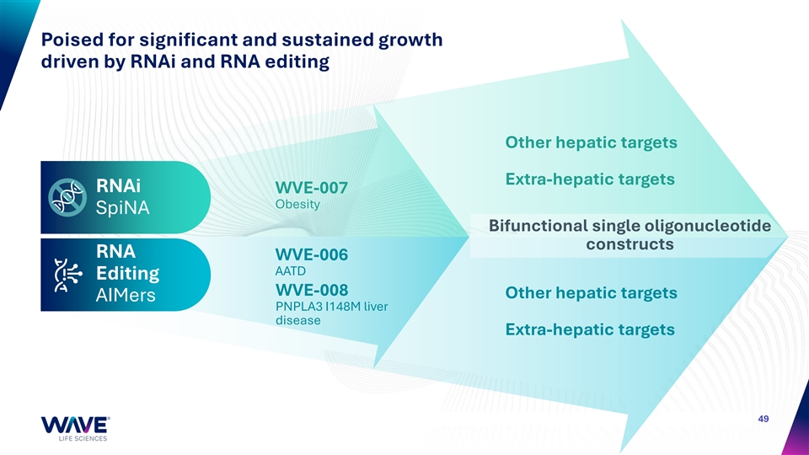
Poised for significant and sustained growth driven by RNAi and RNA editing Other hepatic targets Extra-hepatic targets RNAi WVE-007 Obesity SpiNA Bifunctional single oligonucleotide constructs RNA WVE-006 AATD Editing WVE-008 Other hepatic targets AIMers PNPLA3 I148M liver disease Extra-hepatic targets 49

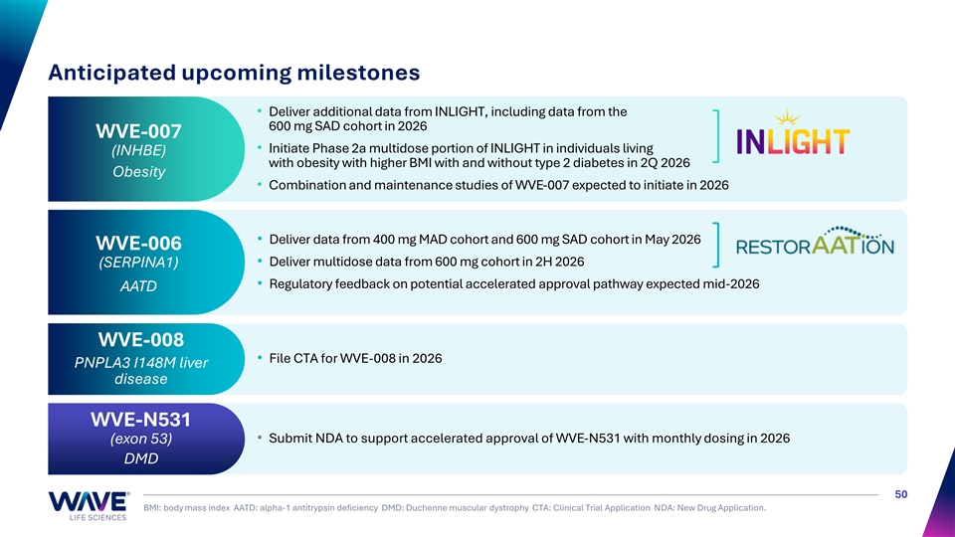
Anticipated upcoming milestones • Deliver additional data from INLIGHT, including data from the 600 mg SAD cohort in 2026 WVE-007 • Initiate Phase 2a multidose portion of INLIGHT in individuals living (INHBE) with obesity with higher BMI with and without type 2 diabetes in 2Q 2026 Obesity • Combination and maintenance studies of WVE-007 expected to initiate in 2026 • Deliver data from 400 mg MAD cohort and 600 mg SAD cohort in May 2026 WVE-006 • Deliver multidose data from 600 mg cohort in 2H 2026 (SERPINA1) • Regulatory feedback on potential accelerated approval pathway expected mid-2026 AATD WVE-008 • File CTA for WVE-008 in 2026 PNPLA3 I148M liver disease WVE-N531 • Submit NDA to support accelerated approval of WVE-N531 with monthly dosing in 2026 (exon 53) DMD 50 BMI: body mass index AATD: alpha-1 antitrypsin deficiency DMD: Duchenne muscular dystrophy CTA: Clinical Trial Application NDA: New Drug Application.


For questions contact: investorrelations@wavelifesci.com

